

**AUTONOMOUS APRON VEHICLE PROTOTYPE**

By

Adi Firman Ilham

001201600041

A Thesis

Submitted to the Faculty of Computer Science

President University

In Partial Fulfillment of the Requirements for

the Degree of Bachelor of Science in Information Technology

Cikarang, Bekasi Indonesia

March 2020

Copyright by

Adi Firman Ilham

2019

**AUTONOMOUS APRON VEHICLE PROTOTYPE**

By

Adi Firman Ilham

001201600041

Approved:

|  |  |
| --- | --- |
| ________________________________  Ir. Rusdianto Roestam, M.Sc, Ph.D.  Thesis Advisor | ________________________________  Nur Hadisukmana, M.Sc  Program Head of Information Technology |

________________________________  
Rila Mandala, Ph.D  
Dean of Faculty of Computing

# DECLARATION OF ORIGINALITY

I hereby certify that I am the sole author of this thesis and that no part of this thesis has been published or submitted for publication.

I certify that, to the best of my knowledge, my thesis does not infringe upon anyone’s copyright nor violate any proprietary rights and that any ideas, techniques, quotations, or any other material from the work of other people included in my thesis, published or otherwise, are fully acknowledged in accordance with the standard referencing practices.

I declare that this is a true copy of my thesis, including any final revisions, as approved by my thesis committee, and that this thesis has not been submitted for a higher degree to any other University or Institution.

I have read the Thesis Regulations and I am aware of the potential consequences of any breach of them.

Cikarang, March 2020

Adi Firman Ilham

# ABSTRACT

Human error causes the most significant number of traffic accident on the road. A breakthrough is needed to provide ease and efficient services in n traffic. The most efficient way to make better and safer traffic is to make vehicles become autonomous. It reduces the probability of accidents caused by human error.

The aircraft passenger proliferates every year. Its growth is the fastest among other transportation modes. An area in the airport that accommodates aircraft for flights is the apron. This area is known as one of the busiest areas in the airport. As the passengers snowball every year, this area will become busier.

This system designs a prototype of autonomous vehicle. The prototype tests the concept and methods used to develop the actual autonomous vehicle as it is the best solution to eliminate human error from the traffic. When implemented at the airport apron, it increases the safety and efficiency of the service. This system consists of two parts: the prototype of the autonomous vehicle based on Arduino and the web application that allows users to interact with the prototype. The prototype can be tracked and monitored remotely using web applications as long as there is an internet connection.

**Keywords:** Autonomous, Apron, Prototype.

# DEDICATION

*I would like to dedicate this research to my beloved family and all friends for their continuous support, prayer and love throughout my life that made me able to complete this phase. I would also like to dedicate this thesis to President University, as a place where I gain knowledge, skills, friends and develop myself.*

*I hope this research can be used for further educational purposes in the academic field.*

# ACKNOWLEDGEMENT

First of all, I would like to express my gratitude to Allah S.W.T for all the love, mercy, and blessing that have been given to me until this day and for the completion of this thesis that entitled "Autonomous Apron Vehicle Prototype".

I realize that this thesis cannot be done without the help and guidance of various parties. Therefore, through this chance, I would like to express my sincere gratitude to:

1. My beloved parents and brother for all the prayers and support for me to finish this thesis.
2. Mr. Rusdianto Roestam as my thesis advisor, who has given me guidance, advice and knowledge in doing this thesis.
3. Mr. Nur Hadisukmana, Ms. Cindy Himawan and all of the Computing faculty lecturers, for all the knowledge.
4. PT Cipta Pernika Nusantara as my office, for all the experiences and lessons that give me insight in doing this thesis and study.
5. Rayi Septipiani Agustina as my office friend who always give me a support for this thesis.
6. I Gede Dharma Pustaka Nantha as my fellow friend who helps me in doing this thesis.
7. Bariza Fahri Galeri as my mentor in the office who always pushes me to work on this thesis.
8. Wiwit Kenny Satrio as my office friend who always tests my patience.
9. Mrs. Octo Ferolina as my finance office who always transfers my salary.
10. Mr. Cindy Prima Sugianto as my office HRD who gives me chance to work in PT Cipta Pernika Nusantara.
11. Mr. Guntur Sujoyono and Mr. Hendra Gunawan as my leader in the office who support me and give me opportunity to explore and extend my skills and potential.
12. Yazida Risqa Haloningtyas and Clarentia Devi Endyasari as my virtual ‘daughters’ who always support me and spare her time to have a sharing session with me.

# **TABLE OF CONTENTS**

DECLARATION OF ORIGINALITY ii

ABSTRACT i

DEDICATION ii

ACKNOWLEDGEMENT iii

TABLE OF CONTENTS v

LIST OF FIGURES ix

LIST OF TABLES xiii

CHAPTER I INTRODUCTION 1

1.1 Background 1

1.2 Problem Statement 2

1.3 Research Objective 3

1.4 Scope and Limitation 3

1.5 Thesis Methodology 4

1.6 Thesis Outline 6

CHAPTER II LITERATURE STUDY 8

2.1 Autonomous Vehicle 8

2.2 Arduino 9

2.2.1 Arduino Uno 9

2.2.2 Software Serial 11

2.3 DC Motor and Wheel 11

2.4 L293D Motor Driver Shield 12

2.5 GPS 15

2.5.1 Coordinate 16

2.5.2 Trilateration 17

2.6 Beitian BN-880 GPS 18

2.6.1 TinyGPS++ 19

2.7 US-100 Ultrasonic Sensor 19

2.8 SIM900 GSM Shield 20

2.9 AT Command 21

2.10 Tracking and Monitoring 21

2.10.1 Tracking 22

2.10.2 Monitoring 22

2.11 Related Work 22

2.11.1 CARDUINO 22

2.11.2 Cakrawala 22

2.12 Comparison Overview 23

CHAPTER III SYSTEMIANALYSIS 24

3.1 System Overview 24

3.2 Functional Analysis 24

3.3 Software Requirements 25

3.4 Hardware Requirements 26

3.5 Use Case Diagram 26

3.6 Use Case Narrative 27

3.7 Swim Lane Activity Diagram 37

CHAPTER IV SYSTEM DESIGN 47

4.1 User Interface Design 47

4.1.1 Login Page 47

4.1.2 Track and Monitoring Page 48

4.2 Prototype System Design 52

4.2.1 Wiring Diagram 53

4.3 Entity Relationship Diagram 54

CHAPTER V SYSTEM IMPLEMENTATION 56

5.1 User Interface Development 56

5.1.1 Login Page Interface 56

5.1.2 Tracking and Monitoring Page Interface 57

5.1.3 Set Destination Panel Interface 58

5.1.4 Track Prototype Movement Panel Interface 59

5.1.5 User Account Interface 60

5.2 Application Details 61

5.2.1 Monitor Prototype 61

5.2.2 Set Destination 63

5.2.3 Track Prototype Movement 65

5.2.4 Read the Destination 67

5.2.5 Move to the Destination 71

5.2.6 Avoid Obstacle 79

5.2.7 Send Coordinate and Heading 81

CHAPTER VI SYSTEM TESTING 82

6.1 Testing Environment 82

6.2 Testing Scenario 82

6.2.1 User Feature Testing 82

6.2.2 Prototype System Feature 85

CHAPTER VII CONCLUSION AND FURTHER WORK 90

7.1 Conclusion 90

7.2 Further Work 91

REFERENCES 92

# LIST OF FIGURES

Figure 1.1 RAD Methodology Key Phases [5] 5

Figure 2.1 Arduino Uno [8] 9

Figure 2.2 DC Motors and wheels [11] 11

Figure 2.3 L293D Motor Driver Shield [13] 12

Figure 2.4 L293D Motor Driver [15] 13

Figure 2.5 74HC595 Shift Register [17] 14

Figure 2.6 Latitude and Longitude [20] 16

Figure 2.7 The Distance Between A Satellite and a GPS [22] 17

Figure 2.8 The Distance Between Three Satellites and A GPS [23] 18

Figure 2.9 Four Satellites Create an Intersection Between Spheres [25] 18

Figure 2.10 Beitian BN-880 GPS and Pins [27] 19

Figure 2.11 US-100 Ultrasonic Sensor [29] 20

Figure 2.12 SIM900 GSM Shield [30] 21

Figure 3.1 Use Case Diagram 27

Figure 3.2 User Login Swim Lane Activity Diagram 38

Figure 3.3 Monitor Prototype Swim Lane Activity Diagram 39

Figure 3.4 Set Destination Swim Lane Activity Diagram 40

Figure 3.5 Tracking Prototype Swim Lane Activity Diagram 41

Figure 3.6 Logout Swim Lane Activity Diagram 42

Figure 3.7 Read Destination Swim Lane Activity Diagram 43

Figure 3.8 Move to The Destination Swim Lane Activity Diagram 44

Figure 3.9 Avoid Obstacle Swim Lane Activity Diagram 45

Figure 3.10 Send Coordinate and Heading Swim Lane Activity Diagram 46

Figure 4.1 Login Page Design 48

Figure 4.2 Tracking and Monitoring Page Design 49

Figure 4.3 Set Destination Panel UI Design 50

Figure 4.4 Track Prototype Movement Panel UI Design 51

Figure 4.5 User Account Panel UI Design 52

Figure 4.6 Wiring Diagram 53

Figure 4.7 Entity Relationship Diagram 54

Figure 5.1 Home Page Interface [43] 57

Figure 5.2 Tracking and Monitoring Page 58

Figure 5.3 Set Destination Panel 58

Figure 5.4 The Prototype Movement Panel 59

Figure 5.5 Playback Interface 60

Figure 5.6 User Account Panel 60

Figure 5.7 Get the Latest Prototype Position 61

Figure 5.8 AJAX Variable to Obtain Prototype Information and Coordinate 61

Figure 5.9 Display Prototype Information Code 62

Figure 5.10 Set Destination Client-side Code 63

Figure 5.11 Set Destination Server-side Code 64

Figure 5.12 Print Destination in the Destination Page Code 64

Figure 5.13 Get Playback Range Code 65

Figure 5.14 Initializing Playback Code 65

Figure 5.15 AJAX Get Playback Code 66

Figure 5.16 Get Playback Server-side Code 66

Figure 5.17 Display Playback Code 66

Figure 5.18 Initializing SIM900 GSM Module and Read the Destination Code 67

Figure 5.19 URL to Read the Destination 68

Figure 5.20 Complete Return Data 68

Figure 5.21 Breaking Down the Return Data Code 69

Figure 5.22 Value of Each Index of Array *Arr* 69

Figure 5.23 Conversion from ASCII to Char 70

Figure 5.24 Store Latitude and Longitude Code 70

Figure 5.25 GPS Library and Global Variables 71

Figure 5.26 Get Current Latitude and Longitude 72

Figure 5.27 Get Current Heading 73

Figure 5.28 Get Heading and Distance to Destination Code 74

Figure 5.29 Getting Values to Adjust Heading 75

Figure 5.30 Left-side Angle Checking Process 75

Figure 5.31 Right-side Angle Checking Process 76

Figure 5.32 Global Variable Declaration to Perform Movement 76

Figure 5.33 Movement Control Code 77

Figure 5.34 Speed and Direction Control Code 78

Figure 5.35 Speed and Movement Code 78

Figure 5.36 Arrive at The Destination Code 79

Figure 5.37 Global Variable to Perform Avoid Obstacle Code 79

Figure 5.38 Initializing US-100 Ultrasonic Sensor Module and Read Obstacle Distance Code 80

Figure 5.39 Avoid Obstacle Code 80

Figure 5.40 Sending Coordinate and Heading Code 81

Figure 5.41 Get GPS Data Server-side Code 81

# LIST OF TABLES

Table 2.1 Arduino Components and Their Function 10

Table 2.2 L293D Motor Driver Pins and Their Function 13

Table 2.3 The Spinning Direction Control [14] 14

Table 2.4 74HC595 Shift Register Pins and Its Function 14

Table 2.5 Feature Comparison with Related Work 23

Table 3.1 Functional Requirements 25

Table 3.2 Software Requirements 25

Table 3.3 Hardware Requirement 26

Table 3.4 Use Case Narrative for User Login 27

Table 3.5 Use Case Narrative for Monitor Prototype 28

Table 3.6 Use Case Narrative for Set Destination 29

Table 3.7 Use Case Narrative for Track Prototype Movement 30

Table 3.8 Use Case Narrative for Logout 32

Table 3.9 Use Case Narrative for Read Destination 33

Table 3.10 Use Case Narrative for Move to the Destination 34

Table 3.11 Use Case Narrative for Avoid Obstacle 35

Table 3.12 Use Case Narrative for Send the Coordinate and Heading 36

Table 4.1 Login Page Design Widgets 48

Table 4.2 Tracking and Monitoring Page Design Widgets 49

Table 4.3 Set Destination Panel Design Widget 50

Table 4.4 Track Prototype Movement Panel Design Widget 51

Table 4.5 User Account Panel Design Widget 52

Table 6.1 User Feature Testing Scenario 82

Table 6.2 User Feature Test Result Capture Screen 83

Table 6.3 Prototype Feature Testing Scenario 85

Table 6.4 Prototype System Feature Result Capture Screen 86

# INTRODUCTION

This introduction chapter is purposed to describe the topic of this thesis, its importance and its process. This section also explains briefly the details of the chapters. This chapter includes six parts, they are: Background, Statement of the Problems, The Objective of the Thesis, The Scope and Limitation, Methodology of Thesis and Outline of Thesis.

## Background

According to data obtained from the Indonesian National Police, three people die every hour caused by traffic accidents. Statistics shows that traffic accidents are caused by several reasons: 61% of them are caused by human error, 9% are caused by vehicle factors, and 30% are caused by facilities and environment [1]. Human error is the most significant factor that contributes to traffic accidents. The elimination of human error through the widespread adoption of autonomous vehicles is thus expected to significantly reduce accidents, with some experts putting the reduction as high as 61%.

Aircraft passengers snowball every year. Based on the Indonesian Ministry of Transportation, from 2014 to 2018, the aircraft passengers grow as high as 9.2% [2]. Executive General Manager of Soekarno Hatta Airport, M. Suriawan Wakan, said that aircraft movement in Soekarno Hatta Airport from January to September 2108 grew as high as 5% while the passenger growth reached 7% [3]. As the passengers grow enormously, the airport must be completed with a better system to enhance the service and increase its efficiency.

An apron is an area in the airport that purposed to accommodate aircraft for refueling, parking, loading or unloading passengers or cargo, or maintenance [4]. There are several vehicles in the apron, such as luggage trucks, passenger buses, refuelers, and catering vehicles. Apron traffic is one of the busiest traffics in the airport as each aircraft needs various apron vehicles to fulfill their needs before the flights. Today’s apron vehicles are operated by humans. Based on the fact that human error is the most significant factor of the traffic accident and the airport passengers are snowballing that increases traffic in the airport, especially in the apron, a breakthrough is needed to prevent the traffic accident in the apron. An autonomous vehicle needs to be implemented in apron vehicles. Autonomous apron vehicle can increase safety because it eliminates human error from the traffic, and it can increase efficiency as it has several advantages, such as it can work faster than humans. It also can work for twenty-four hours without getting exhausted. There are several specific components installed in the autonomous vehicle to record its movement. The data obtained from the autonomous vehicles’ movement can be processed later to give the apron controller more comprehensive information than the non-autonomous vehicle.

This thesis develops a prototype of an autonomous apron vehicle with tracking and monitoring applications. This thesis uses Arduino and several other components to make the prototype of an autonomous apron vehicle. The prototype will move autonomously to the given coordinate and can prevent hitting the obstacle in front of it. This thesis also develops a web application to track the history position and monitor the movement of the prototype.

## Problem Statement

This thesis must be able to solve the following questions:

1. How to increase the work efficiency and safety at the apron.
2. How an autonomous vehicle moves to a determined destination.
3. How vehicles’ movement is recorded and displayed as more comprehensive information.

## Research Objective

The primary aim of this study is the creation of a prototype of an autonomous vehicle prototype by using Arduino as the microcontroller and a web application to monitor and track the prototype. The user sets the destination using the web application. The prototype retrieves the destination and adjusts its heading to the destination and move towards it. The prototype uses an ultrasonic sensor to detect an object so it can prevent hitting an obstacle in front of it by changing its direction. It can adjust its heading to the destination when it moves out of the track. The prototype position obtained from the GPS is sent by using a gsm internet connection to the web application. As for the thing to do is to make an autonomous vehicle prototype that can be tracked and monitored using the web application.

## Scope and Limitation

This thesis focuses on designing an autonomous vehicle prototype with tracking and monitoring application which:

1. The prototype can move autonomously to the determined destination.
2. The web application can track and monitor the prototype position.

The limitation of the prototype and the application are as follows:

1. The prototype reads the destination and sends its position when there is an internet connection.
2. The prototype will move to the destination set by the user in web application as long as there is no obstacle to get GPS signal.
3. The prototype will change its direction if there is an obstacle in front of it.
4. The web application will store the prototype position only based on the data sent from the prototype.
5. The web application will display the latest position of the prototype.

## Thesis Methodology

The development of this thesis uses the Rapid Application Development (RAD) methodology. RAD is a technique for software development that uses limited preparation in favor of rapid prototyping. A prototype is a functionally identical working model to one part of the product. RAD model distributes the phases of research, design, construction, and testing into a sequence of fast, iterative development cycles. Ultimately, the RAD technique has several advantages and disadvantages, such as:

RAD Model advantages are:

1. Changing requirements is easy
2. Measuring the progress is easy.
3. The time for development is way reduced.
4. The component is reusable.
5. Fast initial reviews occur.
6. Encourages customer feedback.

Disadvantages of RAD Model are:

1. Only suitable for systems that are scalable and component-based.
2. Requires user involvement throughout the life cycle.
3. Suitable for project that requires shorter development time.

The RAD model concentrates on the iterative and continuous delivery to the customer of working prototypes. This results in fast delivery to the consumer and consumer engagement during the entire product development process minimizing the risk of non-compliance with the specific user requirements. There are four key phases in the RAD as shown in Figure 1.1.

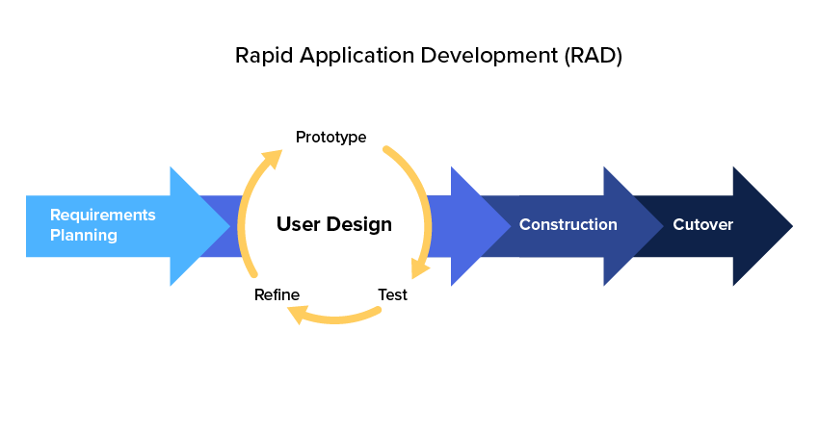

Figure 1.‎I.1 RAD Methodology Key Phases [5]

Below is the explanation of above key phases:

1. Requirements Planning Phase

Users, administrators, and IT team members negotiate and decide on business objectives, project scope, limits, and specifications for the program. It stops when the team decides on the main issues and gets permission from management to proceed.

1. User Design Phase

User Design is a process that allows users to recognize, change, and eventually accept a device operating model that meets their needs. Users communicate with system developers and create models and prototypes representing all structures, inputs and outputs of systems.

1. Construction Phase

This process is where the actual program coding testing and integration happens. Focuses on SDLC-software and device creation functions. Nonetheless, consumers need to engage and may even propose modifications or enhancements in the creation of individual displays or studies.

1. Cutover Phase

This phase is related to the final activities in the deployment process of SDLC, including data transfer, checking, transitioning to a new program and user training. The whole procedure is streamlined relative to conventional approaches. The latest device is then designed, shipped and put into service even earlier.

## Thesis Outline

This thesis consists of the following seven chapters:

1. CHAPTER I: INTRODUCTION

The introduction chapter consist of background study, problem statement, research objective, scope and limitation, methodology, and outline of this thesis.

1. CHAPTER II: LITERATUREISTUDY

This chapter discusses the theoretical supports and methods for creating the program. This chapter provides a description of the tools and citations to topics applicable to this study and related works.

1. CHAPTER III: SYSTEMIANALYSIS

This chapter contains system overview, functional analysis, software requirement, hardware requirement, use case diagram, use case narrative, and swim lane activity diagram.

1. CHAPTER IV: SYSTEMIDESIGN

This chapter addresses in a hierarchical process that includes the steps which are obtained from the elements of the analysis model (Chapter III).

1. CHAPTERIV: SYSTEMIIMPLEMENTATION

This chapter describes the implementation phase for the framework. This chapter is comprised of both source code and system design. This chapter includes a component system design and system detail.

1. CHAPTER VI: SYSTEMITESTING

This chapter takes part in finding the troubleshooting of certain flaws and errors. This chapter performs the testing (Functionality, Quality, and Setting) to make sure that the system accomplishes the requirements.

1. CHAPTERIVII: CONCLUSIONIANDIFUTURE WORK

This chapter contains potential studies which explains the whole analysis arising from application research. This chapter also includes several proposals to develop the program in the future.

# LITERATURE STUDY

This literature study chapter is purposed to define the concepts and methods related to or used in this thesis' development process. The concepts and methods to be explained are as follow: Autonomous vehicle, Arduino, DC Motor and Wheel, L293D Motor Driver Shield, GPS, Beitian-880, US-100 Ultrasonic Sensor, SIM900 GSM Shield, AT Command, Tracking and Monitoring, CodeIgniter, Leaflet, TrackPlayback, and Jquery AJAX. This chapter also explains other related works and the comparison with this thesis.

## Autonomous Vehicle

Autonomous vehicle means a vehicle capable of navigating roadways without a driver actively operating any of the vehicle's control systems [6]. It is a vehicle that is capable of sensing its environment and moving safely with little or no human input. It combines a variety of sensors to perceive their surroundings, such as radar, lidar, sonar, GPS, odometry, and inertial measurement units.

The autonomous vehicle must be guaranteed that it does not damage each other or even human, as stated in the application of Asimov’s laws as follows [7]:

* Every robot action must not hurt humans
* A robot must obey human unless this is contrary to the first law
* A robot must not harm another robot unless this is contrary to the first and second laws.

Thus, the rules above apply to the autonomous vehicle.

## Arduino

Arduino is an open-source circuit board that can be integrated for building electronic projects [8]. The user can program the microcontroller inside the Arduino to control objects. Arduino can interact with various outputs such as motors, and LEDs by processing the inputs from sensors. Arduino is suitable for non-engineer to create hardware projects because it offers a way for them to have access to simple and low-cost tools.

### Arduino Uno

Arduino Uno is one of the Arduino boards. It is the most used and documented Arduino on the market. Arduino Uno provides excellent features and gives the user ease of use so that it has various projects tutorial and forums on the internet. Figure 2.1 below shows the look of Arduino Uno.

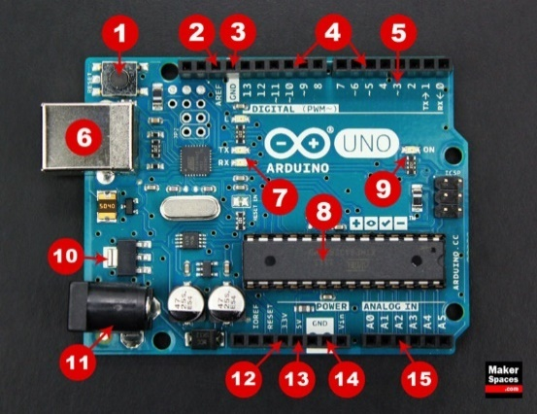

Figure 2.‎II.1 Arduino Uno [8]

Table 2.1 shows the components that build up an Arduino Uno and their function.

Table 2.‎II.1 Arduino Components and Their Function

|  |  |  |
| --- | --- | --- |
| No | Component | Function |
| 1 | Reset Button | To restart the code loaded to the board. |
| 2 | AREF (Analog Reference) | To set an external reference voltage. |
| 3 | Ground Pin | As the ground of the electrical circuit. |
| 4 | Digital Input/Output | Used for digital input or output. |
| 5 | PWM | To simulate analog output. |
| 6 | USB Connection | To power up the board and upload sketch. |
| 7 | TX/RX | Transmit and receive data. |
| 8 | ATmega Microcontroller | To store the programs. |
| 9 | Power LED Indicator | To indicate when the board is plugged in a power source |
| 10 | Voltage Regulator | To control the amount of voltage going into the board. |
| 11 | DC Power Barrel Jack | To power up the board with a power supply. |
| 12 | 3.3V Pin | To supply 3.3 volts of power to the projects. |
| 13 | 5V Pin | To supply 5 volts of power to the projects. |
| 14 | Ground Pins | As the ground of the electrical circuit. |
| 15 | Analog Pins | To read the signal from an analog sensor and convert it to digital. |

### Software Serial

The Arduino hardware has built-in support for serial communication on pins 0 and 1 (which also goes to the computer via the USB connection) [9]. The native serial support happens via a piece of hardware (built into the chip) called a UART. This hardware allows the ATmega chip to receive serial communication even while working on other tasks, as long as there is room in the 64-byte serial buffer.

The SoftwareSerial library has been developed to allow serial communication on other digital pins of the Arduino, using software to replicate the functionality (hence the name "SoftwareSerial"). It is possible to have multiple software serial ports with speeds up to 115200 bps. A parameter enables inverted signaling for devices which require that protocol. The version of SoftwareSerial included in 1.0 and later is based on the NewSoftSerial library by Mikal Hart.

### AltSoftSerial

AltSoftSerial is a library that allow the communication with another serial device by emulating an additional serial port [35]. This library uses pin 8 as RX and 9 TX in Arduino Uno. Unlike the Software Serial that cannot simultaneously transmit and receive and can interference with other libraries or HardwareSerial, this library can simultaneously transmit and receive and has minimal interference with simultaneous use of HardwareSerial and other libraries.

## DC Motor and Wheel

A DC motor (Direct Current motor) is the most common type of motor. DC motors have just two leads, one positive and one negative [10]. The motor will rotate when these two leads connected to the battery. The motor will rotate in the opposite direction when the leads are switched. Two pair of DC gearbox and the motor wheel is shown in Figure 2.2.

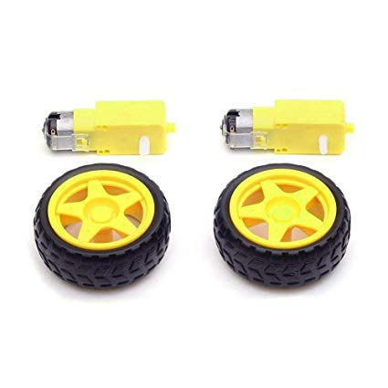

Figure 2.‎II.2 DC Motors and wheels [11]

A circuit called H-Bridge is used to control the direction of the spin of DC motor without interchanging the leads. An H-bridge is an electronic circuit that can drive the motor in both directions. H-bridges are used in many different applications. One of the most common application is to control motors in robots.

PWM or pulse width modulation is a technique that allows the adjustment of the average value of the voltage that is going to the electronic device by turning on and off the power at a fast rate [12]. The average voltage depends on the duty cycle, or the amount of time the signal is ON versus the amount of time the signal is OFF in a single period. So, using these two methods, the PWM and the H-Bridge, the DC motor can be controlled. Many DC motor drivers have these features, and L293D Motor Driver is one of them.

## L293D Motor Driver Shield

L293D Motor Driver Shield is a full-featured motor shield that can control following motors: four DC motors, two stepper motors, and two servo motors [13].

This shield contains two L293D Motor Driver chipsets and a 74HC595 Shift Register. The shift register can extend four digital pins from the Arduino to the eight direction control pins of two L293D Motor Driver chip. Figure 2.3 shows the look of L293D Motor Driver Shield.

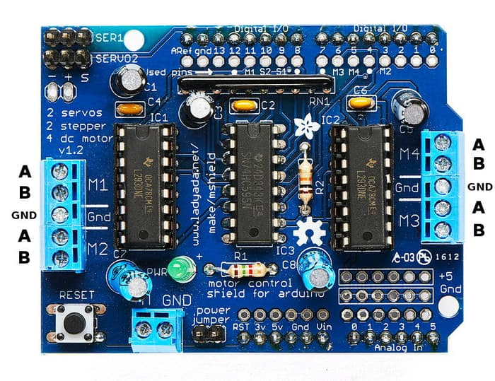

Figure 2.‎II.3 L293D Motor Driver Shield [13]

L293D motor driver shield consists of two L293D drivers and a 74HC595 Shift Register. A single L293D Motor Driver can be used to control two DC motors. Figure 2.4 illustrates L293D Motor Driver.

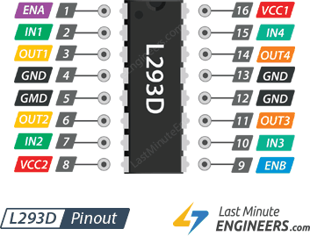

Figure 2.‎II.4 L293D Motor Driver [15]

Table 2.3 shows the pins that build up an L293D Motor Driver and their function.

Table 2.‎II.2 L293D Motor Driver Pins and Their Function

|  |  |
| --- | --- |
| Pin | Function |
| ENA and ENB | To turn ON, OFF, and control speed of motor A and motor B. PWM can also be used to control the speed of the motors. |
| IN1, IN2, IN3, and IN4 | As direction control for motor. IN1 and IN2 controls motor A while IN3 and IN4 controls motor B. |
| OUT1, OUT2, OUT3, and OUT4 | As output channels for motor. The two DC motors can be connected to these terminals. |
| GND | As the ground of the electrical circuit. |
| VCC2 and VCC1 | As power inputs. |

The spinning direction of a motor can be controlled by applying either a logic HIGH (5 Volts) or logic LOW(Ground) to direction control pins (IN1, IN2, IN3, and IN4). Table 2.3 shows the logic to control the spinning direction.

Table 2.‎II.3 The Spinning Direction Control [14]

|  |  |  |
| --- | --- | --- |
| IN1 | IN2 | Spinning Direction |
| 0 | 0 | Motor OFF |
| 1 | 0 | Forward |
| 0 | 1 | Backward |
| 1 | 1 | Motor OFF |

Figure 2.5 below illustrates the 74HC595 Shift Register.

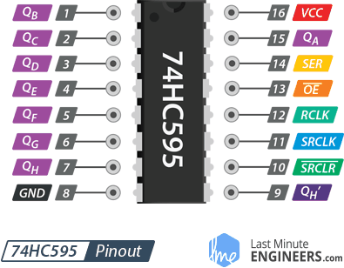

Figure 2.‎II.5 74HC595 Shift Register [17]

Table 2.4 shows the pins that build up a 74HC595 Shift Register and their function.

Table 2.‎II.4 74HC595 Shift Register Pins and Its Function

|  |  |
| --- | --- |
| Pin | Function |
| GND | As the ground of the electrical circuit. |
| VCC | As the power supply connected to the 5V pin on the Arduino. |
| SER (Serial Input) | To feed data into the shift register a bit at a time. |
| SRCLK (Shift Register Clock) | As the clock for the shift register. The 595 is clock-driven on the rising edge. This means that in order to shift bits into the shift register, the clock must be HIGH. And bits are transferred in on the rising edge of the clock. |
| RCLK (Register Clock / Latch) | To store the contents of Shift Register when driven HIGH. |
| SRCLR (Shift Register Clear) | To reset the entire Shift Register, making all its bits 0, at once. This is a negative logic pin, so when no reset is required, this pin should be HIGH. |
| OE (Output Enable) | To enable the output pins (negative logic). |
| QA–QH (Output Enable) | As the output pins. |
| QH’ | To connect to another Shift Register. |

## GPS

Global Positioning System (GPS) is part of satellites that orbiting around the globe [18]. It sends back to earth the details of their position in space. GPS has many uses across various areas. It is also open to every user with a GPS receiver. It has many functions; for example, GPS is usually used for but not limited to; military, weather conditions report, vehicle location tracking, farms, mapping, and many other areas.

A GPS satellite works by sending its signal to the GPS receiver on the ground. Then the GPS receivers passively receive satellite signals. GPS receivers require a clear view of the sky to be able to receive the signal seamlessly, that is why they are usually used or placed outdoors, and when placed within forested area or near tall buildings, they might perform less well (TomTom, 2015). GPS operations are based on a very accurate time reference given by the US naval observatory’s atomic clock. Every GPS satellite has atomic clocks inside it. The Global Positioning System (GPS) uses a satellite network that allows people with GPS receivers to locate wherever they are in the world. It uses two basic mathematical concepts to determine position. The first concept is the relationship between distance, speed, and time. The second concept is called trilateration, which means positioning from three distances.

### Coordinate

Coordinate is a system that uses one or more numbers to uniquely determine the position of a point [19]. Latitude and longitude are used to determine a point on earth’s surface. Latitude is the angular distance of a place north or south of the earth's equator. Longitude is the angular distance of a place east or west of the meridian at Greenwich, England. The Figure 2.6 illustrates the latitude and longitude coordinate.

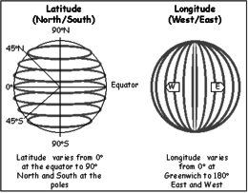

Figure 2.‎II.6 Latitude and Longitude [20]

### Trilateration

Trilateration is a technique to determine a position by measuring the distance using the geometry of circles, spheres, or triangles [21]. GPS uses this technique to determine the location on earth by using GPS satellites and GPS receiver. The satellites broadcast signals that received by GPS on the planet. A satellite broadcasts a signal in all directions. When the signal hits a GPS, the distance between the satellite and the GPS can be obtained by using the mathematical concepts:

distance = speed x time

where speed is the satellite signal speed and time is the amount of time that the signal spent traveling. In the two-dimensional example, the distance forms a circle equal in all directions, as illustrates in Figure 2.7.

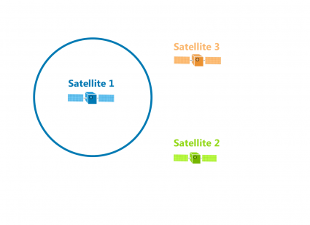

Figure 2.‎II.7 The Distance Between A Satellite and a GPS [22]

The location of the GPS could be anywhere on the circle above. When the GPS receives a second signal, the distance from the second signal creates another circle that means the GPS could be anywhere on the second circle. However, the first and second circle creates two intersections, and the precise location could be any of the two points where the circles intersect. The third satellite signal creates another circle that intersects with the two previous circles. The intersection between three circles shows the exact location of the GPS, as illustrated in the Figure 2.8.

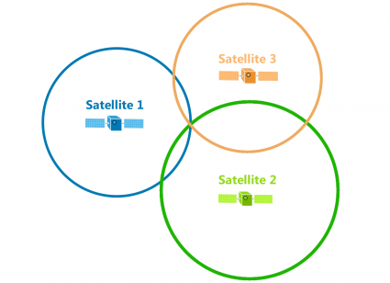

Figure 2.‎II.8 The Distance Between Three Satellites and A GPS [23]

In the real three-dimensional world, the satellites broadcast signals as a sphere and at least four satellites are needed to work out the accurate position in three-dimension [24]. Each satellite is at the centre of the sphere. The intersection of all spheres determines the position of the GPS. The Figure 2.9 below illustrates the intersection between spheres.

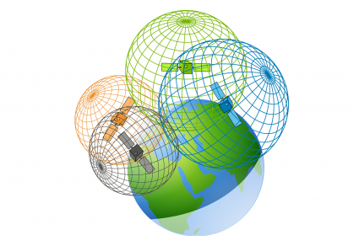

Figure 2.‎II.9 Four Satellites Create an Intersection Between Spheres [25]

## Beitian BN-880 GPS

Beitian BN-880 is a GPS module that also includes HMC5883L Compass. It is a GPS unit with a magnetometer (compass) suitable for full navigation capability in INAV and similar systems [26]. It can receive these satellite positioning systems formats: GPS, GLONASS, Galileo, BeiDou, QZSS, and SBAS. Its accuracy of level positioning precision is 2m at the open wind. The Figure 2.10 shows the Beitian BN-880 GPS and its functional pin.

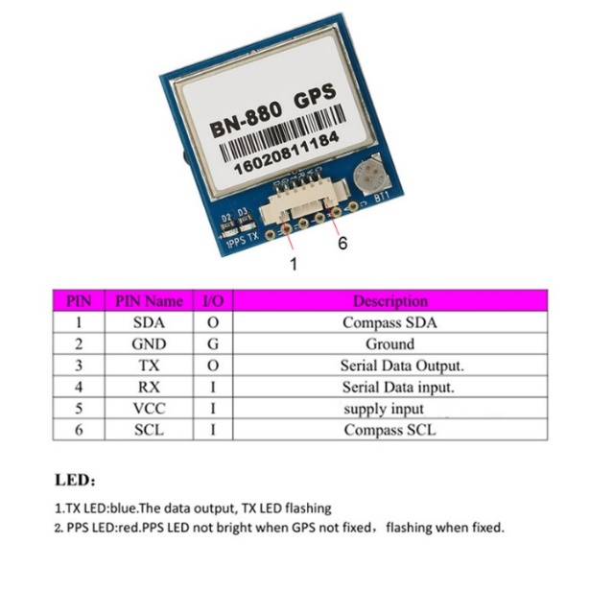

Figure 2.‎II.10 Beitian BN-880 GPS and Pins [27]

### TinyGPS++

TinyGPS++ is a compact Arduino NMEA (GPS) parsing library [28]. It is a new Arduino library for parsing NMEA data streams provided by GPS modules. Like its predecessor, TinyGPS, this library provides compact and easy-to-use methods for extracting position, date, time, altitude, speed, and course from consumer GPS devices.

However, TinyGPS++’s programmer interface is considerably more straightforward to use than TinyGPS, and the new library can extract arbitrary data from any of the myriad NMEA sentences out there, even proprietary ones.

## US-100 Ultrasonic Sensor

US-100 Ultrasonic Sensor is a module that used to detect the distance between the module and the object. This module uses the ultrasonic sensor, and it can detect an object in the range of 2 cm to 4.5 m distance. The US-100 module is shown in Figure 2.11.

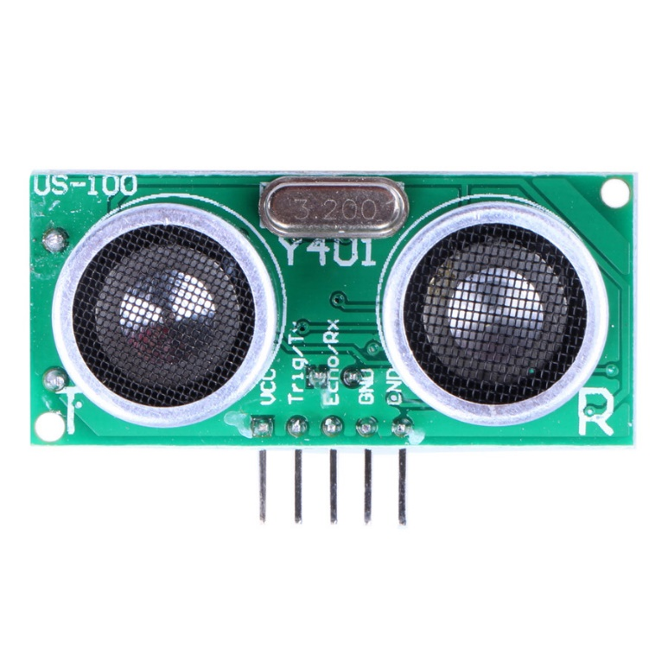

Figure 2.‎II.11 US-100 Ultrasonic Sensor [29]

## SIM900 GSM Shield

The GPRS/GSM Shield provides a way to use the GSM cell phone network to receive data [30]. The shield allows the user to achieve this via any of the three methods:

• Short Message Service

• Audio

• GPRS Service

The GPRS Shield is compatible with all boards which have the same form factor (and pinout) as a standard Arduino Board. The GPRS Shield is configured and controlled via its UART using simple AT commands. Based on the SIM900 GSM module from SIMCOM, the GPRS Shield is like a cell phone. Besides the communications features, the GPRS Shield has 12 GPIOs, 2 PWMs and an ADC. The Figure 2.12 below shows the SIM900 GSM Shield.

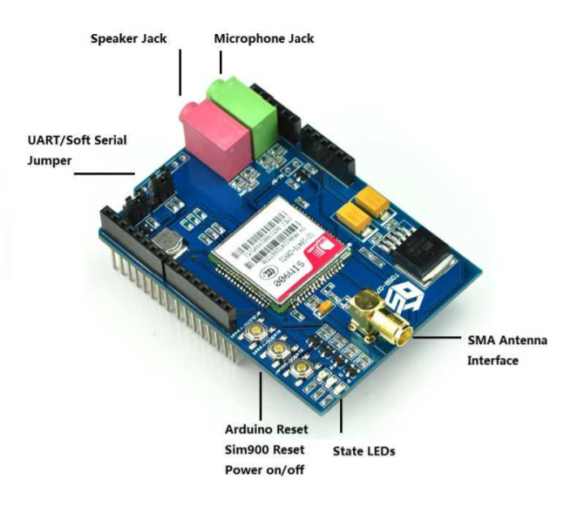

Figure 2.‎II.12 SIM900 GSM Shield [30]

## AT Command

AT commands are instructions used to control a modem [31]. The AT is the abbreviation of ATtention. Every command line starts with "AT" or "at". That is why modem commands are called AT commands. Many of the commands that are used to control wired dial-up modems, such as ATD (Dial), ATA (Answer), ATH (Hook control) and ATO (Return to online data state), are also supported by GSM/GPRS modems and mobile phones. Besides this common AT command set, GSM/GPRS modems and mobile phones support an AT command set that is specific to the GSM technology, which includes SMS-related commands like AT+CMGS (Send SMS message), AT+CMSS (Send SMS message from storage), AT+CMGL (List SMS messages) and AT+CMGR (Read SMS messages).

## Tracking and Monitoring

This section explains the tracking and monitoring system.

### Tracking

A tracking system is used for the observation of persons or objects on the move and supplying a timely ordered sequence of location data for further processing. Tracking usually means looking for footprints in order to hunt down something or someone or to locate a device and have a history of GPS positions.

### Monitoring

A monitoring system is an instrument or device used for observing, checking, or keeping a continuous record of a process or quantity. Monitoring means keeping an eye on a person's or object's movements.

## Related Work

This section shows the works that suggests a different concept or method to tackle the same problem. The related works can also the work that applies the same approach to solve another problem.

### CARDUINO

CARDUINO is an effort to develop an autonomous public vehicle using simple and low-cost microcontroller, Arduino [32]. This prototype uses an ultrasonic sensor to detect the obstacles. This system is developed by Rahmad Martin as his thesis for the Bachelor's Degree in Science at President University in the year of 2015.

### Cakrawala

Cakrawala is a web application for tracking and monitoring vehicles [33]. This application can display the latest position of the vehicle and the history position as well. The thesis writer is developing this application in his internship period.

## Comparison Overview

Table 2.2 shows the differences between this thesis and related works.

Table 2.‎II.5 Feature Comparison with Related Work

|  |  |  |  |
| --- | --- | --- | --- |
| Feature | Cakrawala | CARDUINO | Autonomous Apron Vehicle Prototype |
| Prototype moves to the determined destination | ✗ | ✓ | ✓ |
| Prototype moves in the heading range that makes it stable | ✗ | ✗ | ✓ |
| Prototype prevents hitting obstacles | ✗ | ✓ | ✓ |
| User can track vehicle movement | ✓ | ✗ | ✓ |
| User can monitor vehicle | ✓ | ✗ | ✓ |
| User can control the vehicle from anywhere | ✗ | ✗ | ✓ |

# SYSTEMIANALYSIS

This chapter aims to analyze system structure and behavior analysis based on the stated requirements to define its aims and purpose. This chapter explains the application requirements and implementation process. This chapter consists of System Overview, Comparison Overview, Functional Requirement, Hardware Requirement, Software Requirement, Use Case Diagram, Use Case Narrative, and Swim Lane Diagram.

## System Overview

The main objectives of this thesis are to create an autonomous apron vehicle prototype that can move autonomously to the given destination and to create application that can track and monitor the prototype position. This system is applied using Arduino Uno for the microcontroller of the sensors. This system will use a GPS module to obtain vehicle coordinates and heading and a GSM module to transmit that GPS data to the web server. The tracking and monitoring will be performed by using web application. This thesis is created in order to increase safety and efficiency by implementing autonomous apron vehicle with tracking and monitoring application.

## Functional Analysis

There are some requirements needed to achieve the targets. The functional analysis requirements are the main objective of the complete implemented system. Table 3.1 shows the functional requirements for this thesis.

Table 3.‎III.1 Functional Requirements

|  |  |
| --- | --- |
| **No** | **Functional Requirements** |
| 1 | The prototype can move to the given destination. |
| 2 | The prototype can avoid hitting the obstacle. |
| 3 | The GPS data can be sent to the web server using GSM internet connection. |
| 4 | The application can be operated in a browser. |
| 5 | The application can show the past and latest position of the prototype. |

## Software Requirements

This thesis requires application development tools and libraries to achieve expected results. Table 3.2 shows the requirement for the software used in this thesis.

Table 3.‎III.2 Software Requirements

|  |  |  |
| --- | --- | --- |
| **No** | **Software Requirement** | **Function** |
| 1 | Arduino IDE | As the main environment to develop the prototype system. |
| 2 | Microsoft Word 2019 | To create the documentation of this thesis. |
| 3 | Visual Studio Code | To develop the web application. |
| 4 | Draw.ioI | To design the use case diagram, activity diagram, and entity relationship diagram. |
| 5 | Google Chrome | To run the web application |
| 6 | Web Server | To store GPS data and other data. |

## Hardware Requirements

Table 3.3 shows the requirement for the hardware used in this thesis.

Table 3.‎III.3 Hardware Requirement

|  |  |  |  |
| --- | --- | --- | --- |
| **No** | **Hardware Requirement** | **Function** | **Pcs** |
| 1 | Laptop | To run software needed in the development process. | 1 Pcs |
| 2 | Arduino Uno | To develop prototype system. | 1 Pcs |
| 3 | GPS Module | To obtain GPS data. | 1 Pcs |
| 4 | GSM Module and SIM card | To send GPS data to the web server. | 1 Pcs |
| 5 | Jumper Cable | Used as the connector between components in Arduino Uno. | 1 Set |
| 6 | Ultrasonic Sensor Module | To detect obstacle. | 1 Pcs |
| 7 | DC Gearbox Motor and Wheel | To accelerate the prototype. | 1 Pcs |
| 8 | Power Supply 9V – 12V DC | To supply the power for the prototype. | 2 Pcs |
| 9 | Driver Shield L293 | To run the motor. | 1 Pcs |

## Use Case Diagram

Use Case Diagram is a graphic overview from an actor or several actors, use case, and interaction that explains the brief of the system. Use Case Diagram shows processIflowIwhenItheIsystem works from the user’s perspective: Actor (internalIor externalIfactors interacting with theIsystem), UseICases (sequencesIactions that provide an actor with some measurable value), Associations, and System Boundary. Figure 3.1 shows the use case diagram of prototype and application system.

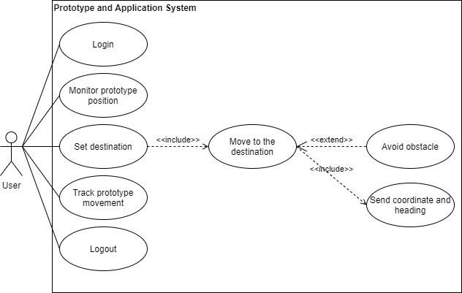

Figure 3.‎III.1 Use Case Diagram

## Use Case Narrative

A use case narrative is a written illustration of the sequence of events that happens throughout an actor-system encounter. The use case narrative is explained in tables like the name, description, precondition, event, postcondition, and business rule in the system. Table 3.4 until Table 3.11 reflect the system’s use case narrative.

Table 3.‎III.4 Use Case Narrative for User Login

|  |  |  |
| --- | --- | --- |
| Name | Login | |
| IDIII | UC01iii | |
| Primary Business Actor | User | |
| Primary System Actor | Application | |
| Other Participating Actor | None | |
| Description | The event when the user logs in to the application. | |
| Precondition | None | |
| Trigger | User logs in to the application. | |
| Typical Course of Event | **Actor Action** | **System Response** |
| Step 1: User enters username and password and logs in to the application. |  |
|  | Step 2: The system validates username and password. |
|  | Step 3: The system redirects the user to tracking and monitoring page. |
| Post Condition | The user is logged in. | |
| Business Rule | * The system must be connected to the internet. | |

Table 3.‎III.5 Use Case Narrative for Monitor Prototype

|  |  |  |
| --- | --- | --- |
| Name | Monitor prototype | |
| IDIII | UC02iii | |
| Primary Business Actor | User | |
| Primary System Actor | Application | |
| Other Participating Actor | None | |
| Description | The event when the user monitors the latest position of the prototype. | |
| Precondition | The user is logged in. | |
| Trigger | The user opens the application. | |
| Typical Course of Event | **Actor Action** | **System Response** |
|  | The user logs in to the application. |  |
|  |  | Step 1: System loads the prototype data. |
|  |  | Step 2: System retrieves the latest data in table coordinate. |
|  |  | Step 3: System displays the prototype data. |
|  | Step 3: User views the latest position of the prototype. |  |
|  | Step 4: User clicks the prototype icon. |  |
|  |  | Step 5: System shows the prototype info in a popup. |
| Post Condition | The application displays prototype’s latest position. | |
| Business Rule | * The system must be connected to the internet. | |

Table 3.‎III.6 Use Case Narrative for Set Destination

|  |  |  |
| --- | --- | --- |
| Name | Set destination | |
| IDIII | UC03iii | |
| Primary Business Actor | User | |
| Primary System Actor | Application | |
| Other Participating Actor | None | |
| Description | The event when the user decides to set a new destination for the vehicle prototype. | |
| Precondition | The user is logged in. | |
| Trigger | The user selects the destination. | |
| Typical Course of Event | **Actor Action** | **System Response** |
|  |  |  |
|  | Step 2: User selects the destination |  |
|  |  | Step 3: System updates table *vehicle.* |
|  |  | Step 4: System prints updated destination in page destination. |
| Post Condition | The application sets new destination. | |
| Business Rule | * The system must be connected to the internet. | |

Table 3.‎III.7 Use Case Narrative for Track Prototype Movement

|  |  |  |
| --- | --- | --- |
| Name | Track prototype movement | |
| IDIII | UC04 | |
| Primary Business Actor | User | |
| Primary System Actor | System | |
| Other Participating Actor | None | |
| Description | This use-case describes the event when the user tracks the past position/movement of the prototype. | |
| Precondition | The user has logged in. | |
| Trigger | The user selects starting and finishing date to generate playback. | |
| Typical Course of Event | **Actor Action** | **System Response** |
|  |  |
| Step 2: User selects starting and finishing date to generate playback. |  |
|  | Step 3: System retrieves data from table *coordinate.* |
| Step 4: User plays the animation of past movements |  |
| Post Condition | System displays vehicle’s past position. | |
| Business Rule | * The system must be connected to the internet. | |

Table 3.‎III.8 Use Case Narrative for Logout

|  |  |  |
| --- | --- | --- |
| Name | Logout | |
| IDIII | UC05III | |
| Primary Business Actor | User | |
| Primary System Actor | Application | |
| Other Participating Actor | None | |
| Description | The event when the user decides to logout from the application. | |
| Precondition | The user has logged in. | |
| Trigger | The user to logs out from the application. | |
| Typical Course of Event | **Actor Action** | **System Response** |
|  |  |
| Step 2: User logs out from the application. |  |
|  | Step 3: System deletes session. |
|  | Step 4: System redirects the user to login page. |
| Post Condition | The user is logged out from the application. | |
| Business Rule | * The system must be connected to the internet. | |

Table 3.‎III.9 Use Case Narrative for Move to the Destination

|  |  |  |
| --- | --- | --- |
| Name | Move to the destination | |
| IDIII | UC07III | |
| Primary Business Actor | User | |
| Primary System Actor | Prototype | |
| Other Participating Actor | None | |
| Description | The event when the prototype moves towards the destination. | |
| Precondition | None | |
| Trigger | The prototype gets the destination coordinate. | |
| Typical Course of Event | **Actor Action** | **System Response** |
| Stepi1: User sets destination. |  |
|  | Step 2. Prototype system reads the destination |
|  | Step 3: Prototype system obtains coordinate and heading. |
|  | Step 4: Prototype system calculates distance and heading to the destination. |
|  | Step 5: Prototype system adjusts its heading towards destination. |
|  | Step 6: Prototype system moves towards destination. |
|  | Step 7: Prototype system arrives at the destination. |
| Post Condition | Prototype has arrived at the destination. | |
| Business Rule | * The system must be connected to the internet. * Vehicle prototype able to receive GPS signal. | |

Table 3.‎III.10 Use Case Narrative for Avoid Obstacle

|  |  |  |
| --- | --- | --- |
| Name | Avoid obstacle | |
| IDIII | UC08III | |
| Primary Business Actor | User | |
| Primary System Actor | Prototype | |
| Other Participating Actor | None | |
| Description | This use-case defines the case when the prototype avoids hitting obstacle. | |
| Precondition | None | |
| Trigger | Obstacle in front of the prototype. | |
| Typical Course of Event | **Actor Action** | **System Response** |
| Stepi1: User sets the destination. |  |
|  | Stepi2: Prototype system calculates distance with obstacle in front of it. |
|  | Step 3: Prototype avoids the obstacle. |
| Post Condition | None | |
| Business Rule | None | |

Table 3.‎III.11 Use Case Narrative for Send the Coordinate and Heading

|  |  |  |
| --- | --- | --- |
| Name | Send coordinate and heading | |
| IDIII | UC09 | |
| Primary Business Actor | User | |
| Primary System Actor | Prototype | |
| Other Participating Actor | Application | |
| Description | This use-case defines the case when the prototype sends the coordinate and heading. | |
| Precondition | None | |
| Trigger | Prototype movement | |
| Typical Course of Event | **Actor Action** | **System Response** |
| Stepi1: User sets the destination |  |
|  | Stepi2: Prototype sends current coordinate and heading. |
|  | Step 3: System receives the coordinate and heading. |
|  |  | Step 4: System insert data to table *coordinate*. |
| Post Condition | The heading and coordinate are stored in the database. | |
| Business Rule | * The system must be connected to the internet. | |

## Swim Lane Activity Diagram

A swim lane activity diagram shows visually a series of actions and control flow in a system, basically a flowchart to represent the flow from one activity to another. An activity can be described as system operation. Control flow is drawn between operations.

1. Application Activity

There are five activity diagrams that includes application system as the system actor. Figure 3.2 shows the activity diagram for login. Figure 3.3 shows the activity diagram for monitoring prototype. Figure 3.4 shows the activity diagram for setting the destination. Figure 3.5 shows the activity diagram for tracking prototype movement. Figure 3.6 shows the activity diagram for logout.

1. Prototype System Activity

There are four activities diagram that includes prototype system as the actor. First, Figure 3.7 shows the activity diagram for reading the destination. Second, Figure 3.8 shows the activity diagram for moving to the destination. Third, Figure 3.9 shows the activity diagram for avoiding obstacle. Lastly, Figure 3.10 shows the activity diagram for sending coordinate and heading.

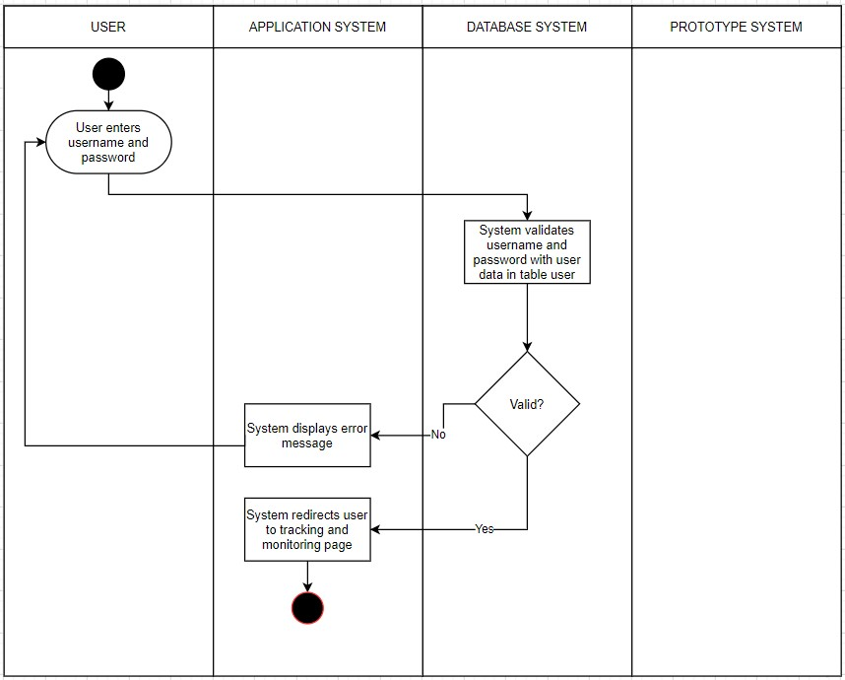

Figure 3.‎III.2 User Login Swim Lane Activity Diagram

Figure 3.2 shows the diagram of Login Activity, starting with the user inputs their username, password and logs in to the application. The system validates the username and password. If the user enters a valid username and password the system redirects the user to tracking and monitoring page.

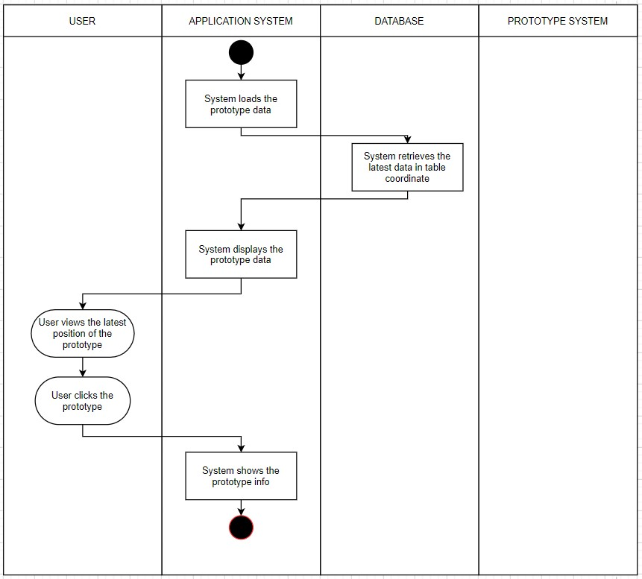

Figure 3.‎III.3 Monitor Prototype Swim Lane Activity Diagram

Figure 3.3 shows the diagram of Monitor Prototype Activity, starting with the system loads the prototype data and displays it on the map. The user can see the latest position of the prototype on the map. When the user clicks the prototype, the system will display a window containing prototype information.

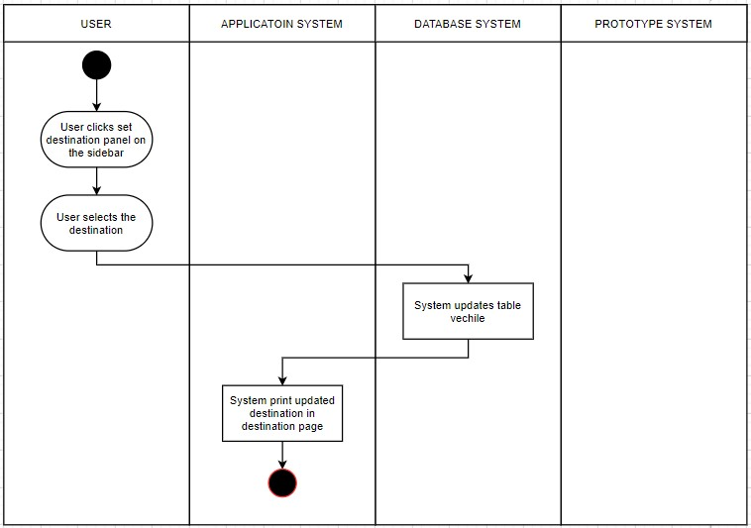

Figure 3.‎III.4 Set Destination Swim Lane Activity Diagram

Figure 3.4 shows the diagram of Set Destination Activity, starting with the user clicks set destination panel on the sidebar. After that, user selects the destination and the system updates table vehicle. The system prints the updated destination in page destination.

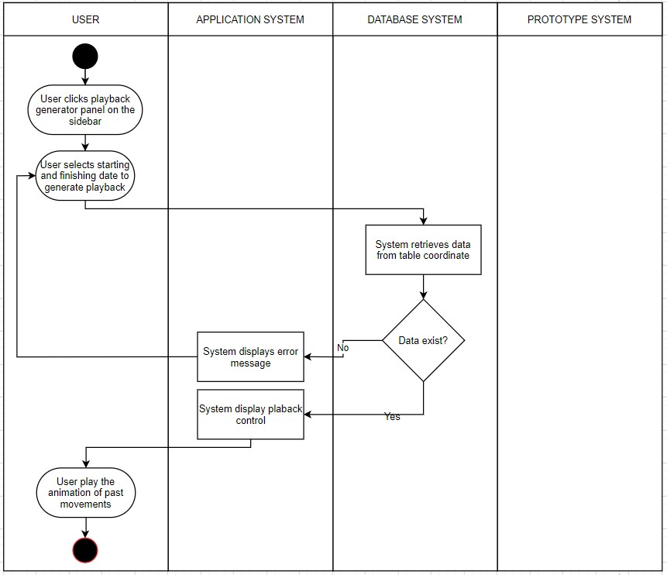

Figure 3.‎III.5 Tracking Prototype Swim Lane Activity Diagram

Figure 3.5 shows the diagram of Tracking Prototype Activity, starting with the user clicks playback generator panel on the sidebar. After that, user can input the starting and finishing date of the playback. The system retrieves the data based on the range given by the user and display the playback on the map. The user then plays the animation of prototype’s movement.

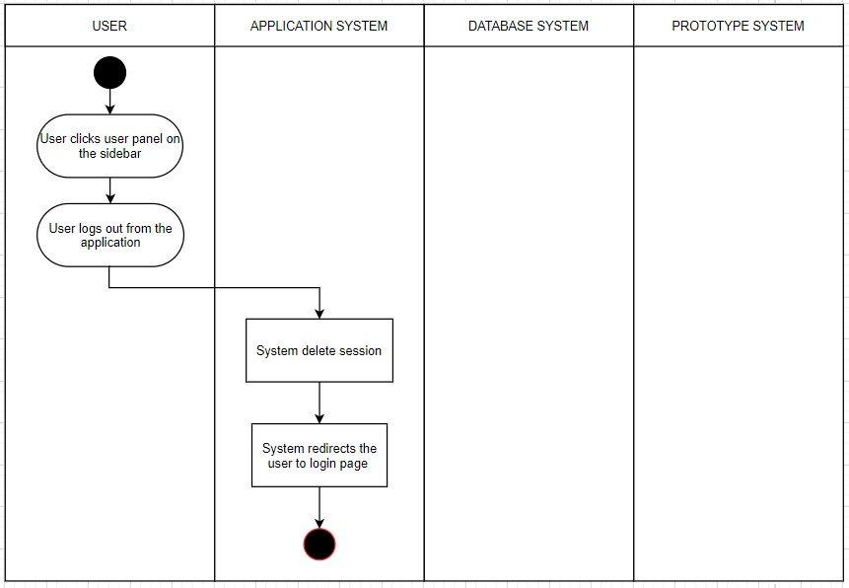

Figure 3.‎III.6 Logout Swim Lane Activity Diagram

Figure 3.6 shows the diagram of Logout Activity, starting with the user clicks user account panel on the sidebar and logs out from the application. The system deletes the user’s session and redirects them to the login page.

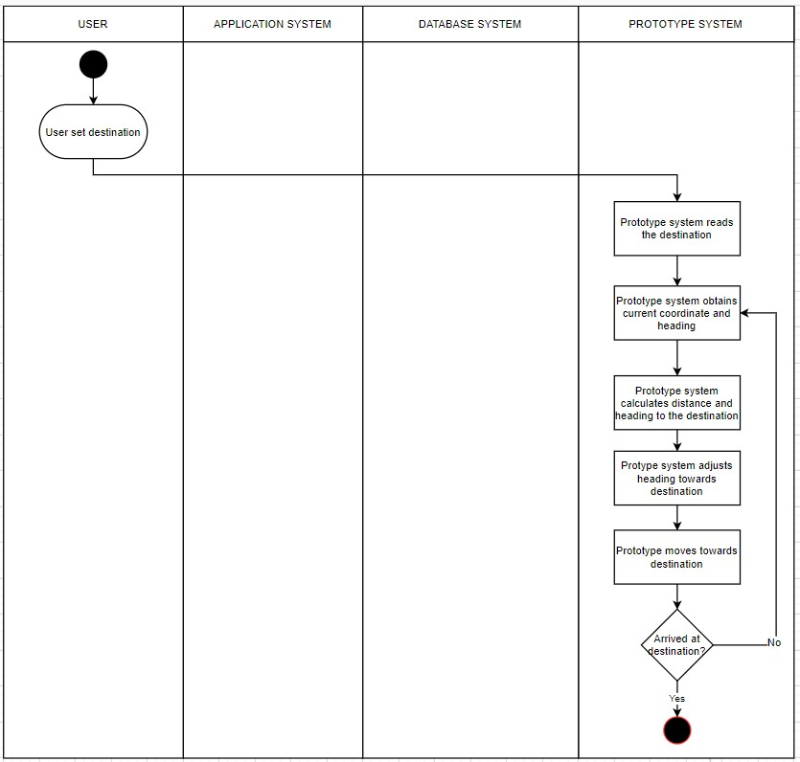

Figure 3.‎III.7 Move to The Destination Swim Lane Activity Diagram

Figure 3.7 shows the diagram of Move to the Destination Activity, starting with the user sets the destination. The prototype system starts its movement by reading the destination. After that, the prototype obtains its coordinate and heading and calculates the destination distance and heading. The prototype then adjusts its heading and move forwards. The prototype repeats above steps until it reached the destination.

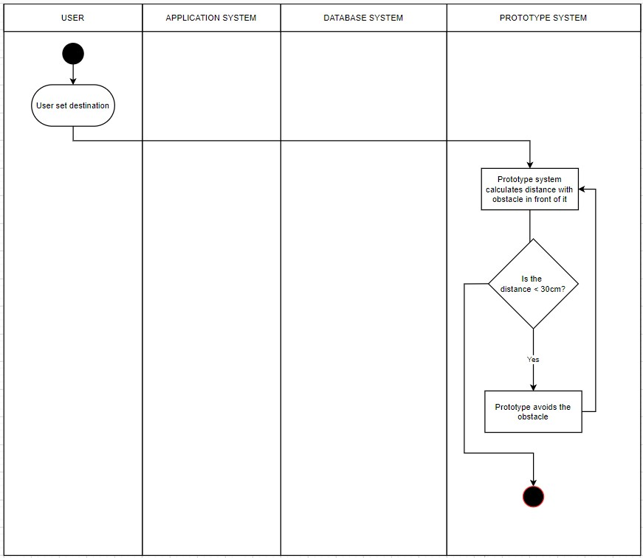

Figure 3.‎III.8 Avoid Obstacle Swim Lane Activity Diagram

Figure 3.8 shows the diagram of Avoid Obstacle activity, starting with the user sets the destination. The prototype system calculates the obstacle distance in front of it. If the distance is less than 30 cm the prototype system performs certain movement to avoid the obstacle.

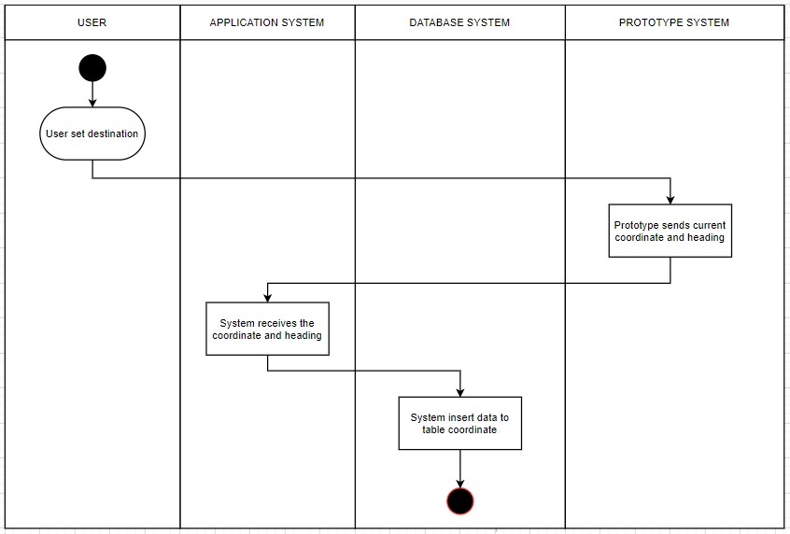

Figure 3.‎III.9 Send Coordinate and Heading Swim Lane Activity Diagram

Figure 3.9 shows the diagram of Send Coordinate and Heading activity, starting with the user sets the destination. The prototype system sends its coordinate and heading. The application system received that coordinate and heading and store them into the database.

# SYSTEM DESIGN

This chapter defines the components, interfaces, and data required to accomplish the system requirements. This chapter consists of three sections: User Interface Design, Prototype System Design, and Entity Relationship Diagram.

## User Interface Design

User interface design is the application's most important component. The user interface is a visualization part of the program and a way to communicate program and user. A good user interface design should allow users to easily, efficiently use the application hence resulting in high productivity. The user interface will be a factor for using and testing the application.

This application will have two interfaces (on separate pages) which serve distinct functions.

### Login Page

Figure 4.1 shows the Login Page of the application. It has two textboxes and a button. The textboxes are used to enter username and password while the button used to login to the application. Table 4.1 shows the function of each widget displayed in the Figure 4.1.

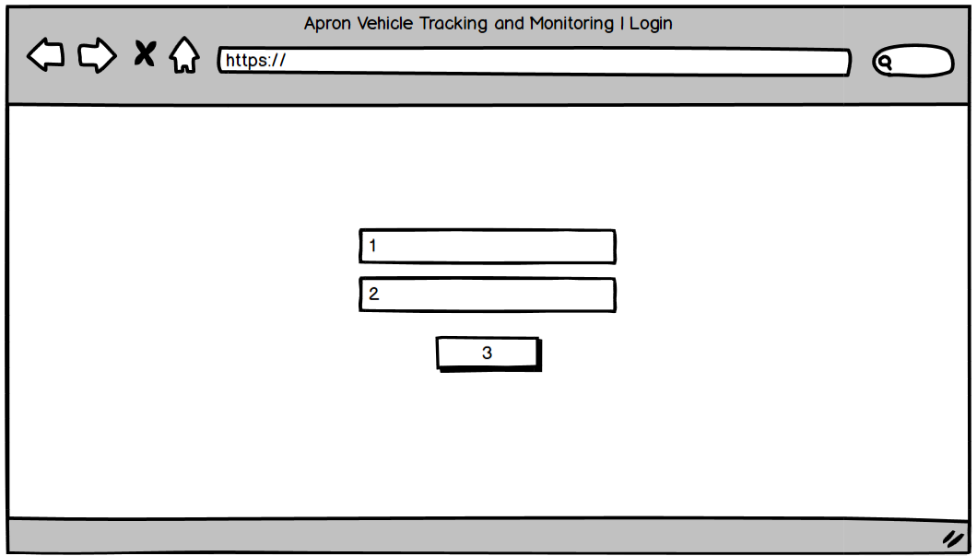

Figure 4.‎IV.1 Login Page Design

Table 4.‎IV.1 Login Page Design Widgets

|  |  |  |
| --- | --- | --- |
| **No** | **Name** | **Function** |
| 1 | Username Textbox | To allow the user to input username |
| 2 | Password Textbox | To allow the user to input password |
| 3 | Login Button | To allow user to log into the application |

### Track and Monitoring Page

Figure 4.2 Shows the Track and Monitoring Page. There is a Map Section that shows a full-screen map. There is a sidebar on the right. There are three buttons on the sidebar. Each button is used to show a panel. Table 4.2 shows the function of each widget displayed in the Figure 4.2.

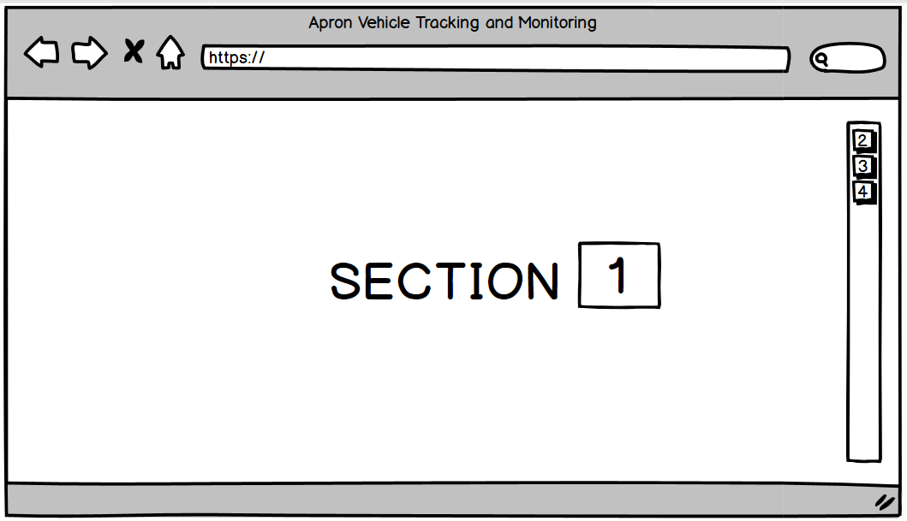

Figure 4.‎IV.2 Tracking and Monitoring Page Design

Table 4.‎IV.2 Tracking and Monitoring Page Design Widgets

|  |  |  |
| --- | --- | --- |
| **No** | **Name** | **Function** |
| 1 | Map Section | A section to display map |
| 2 | Set Destination Button | To display set destination panel |
| 3 | Playback Generator Button | To display playback panel |
| 4 | User Button | To display user panel |

Figure 4.3 shows the Set Destination Panel. This panel consist of a combo box, and a button. The combo box is used to select the destination. The button is used set the selected destination. Table 4.3 shows the function of each widget displayed in the Figure 4.3.

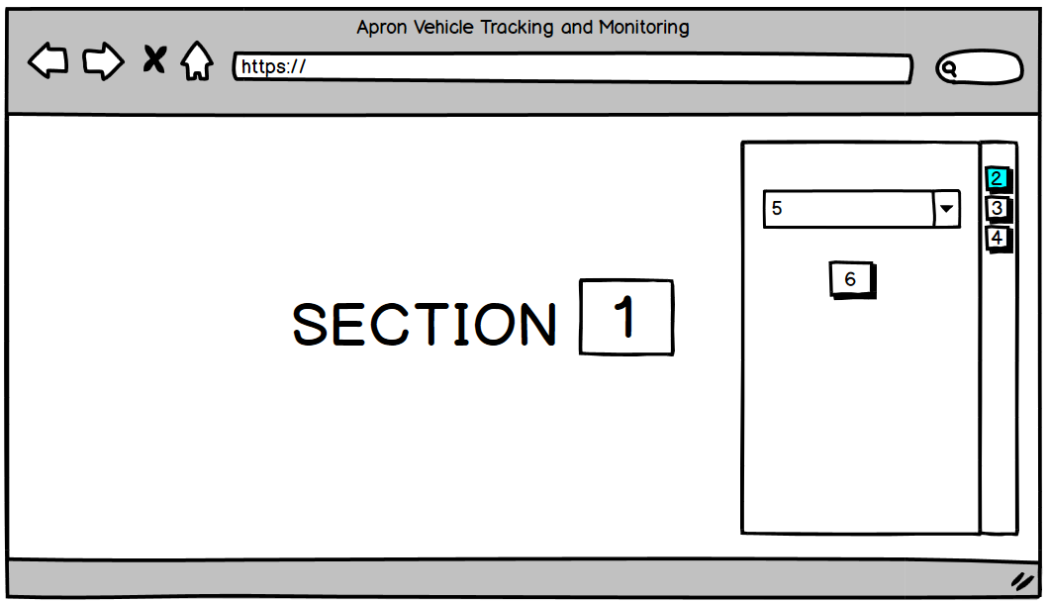

Figure 4.‎IV.3 Set Destination Panel UI Design

Table 4.‎IV.3 Set Destination Panel Design Widget

|  |  |  |
| --- | --- | --- |
| **No** | **Name** | **Function** |
| 1 | Map Section | A section to display map |
| 2 | Set Destination Button | To display set destination panel |
| 3 | Playback Generator Button | To display playback panel |
| 4 | User Button | To display user panel |
| 5 | Destination Combo Box | To allow the user to select destination |
| 6 | Send Button | To set the destination |

Figure 4.4 shows the Track Prototype Movement Panel. This panel consist of two text inputs and a button. The first text input is used to enter the starting date while the second text input is used to enter the finishing date. The button is used to generate the vehicle movement between those starting and finishing date. Table 4.4 shows the function of each widget displayed in the Figure 4.4.

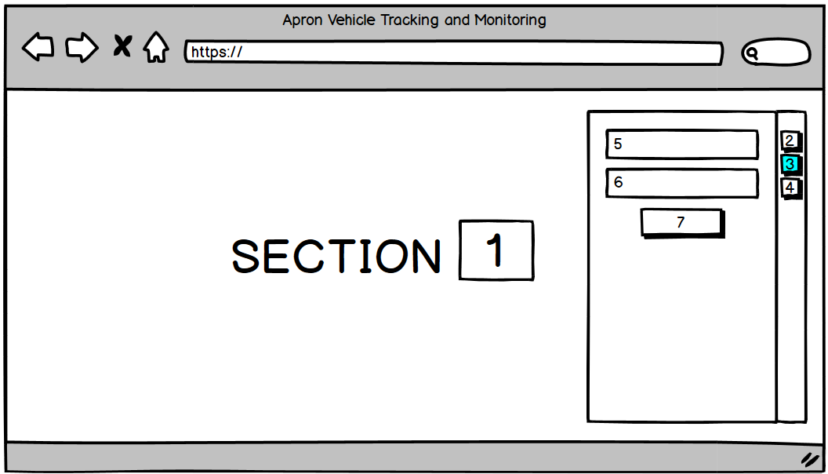

Figure 4.‎IV.4 Track Prototype Movement Panel UI Design

Table 4.‎IV.4 Track Prototype Movement Panel Design Widget

|  |  |  |
| --- | --- | --- |
| **No** | **Name** | **Function** |
| 1 | Map Section | A section to display map |
| 2 | Set Destination Button | To display set destination panel |
| 3 | Playback Generator Button | To display playback panel |
| 4 | User Button | To display user panel |
| 5 | Starting Date Textbox | To allow the user to input starting date |
| 6 | Finishing Date Textbox | To allow the user to input finishing date |
| 7 | Generate Button | To generate playback |

Figure 4.5 shows the User Account Panel. This panel consist of a button to logout from the application. Table 4.5 shows the function of each widget displayed in the Figure 4.5.

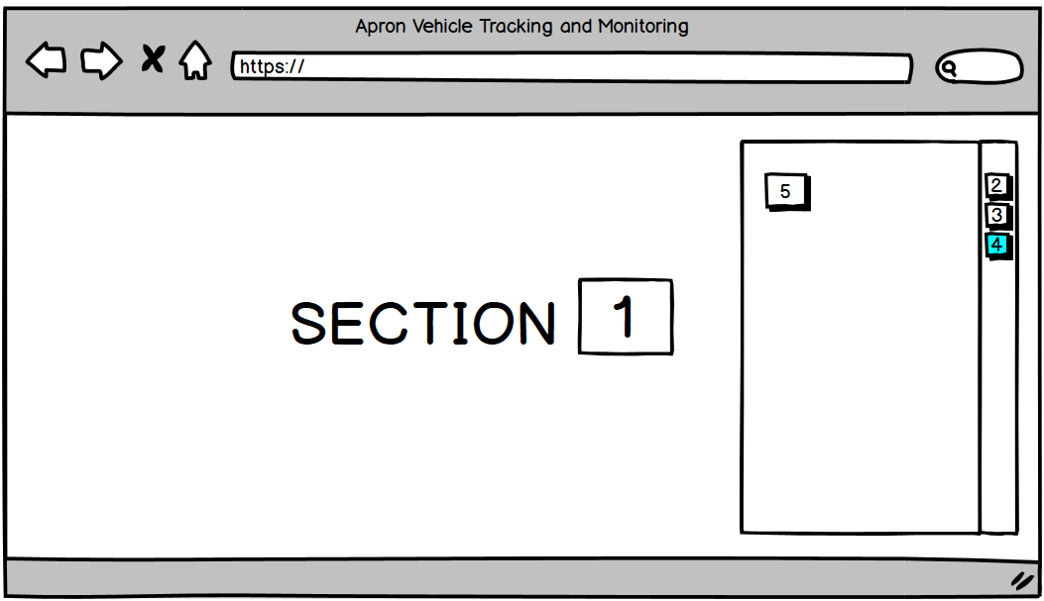

Figure 4.‎IV.5 User Account Panel UI Design

Table 4.‎IV.5 User Account Panel Design Widget

|  |  |  |
| --- | --- | --- |
| **No** | **Name** | **Function** |
| 1 | Map Section | A section to display map |
| 2 | Set Destination Button | To display set destination panel |
| 3 | Playback Generator Button | To display playback panel |
| 4 | User Button | To display user account panel |
| 5 | Logout Button | To logout from the application |

## Prototype System Design

This section explains how the Prototype System is implemented. This phase results in the Wiring Diagram and Entity Relationship Diagram that will be implemented in this thesis.

### Wiring Diagram

The wiring diagram is the design of the implementation of the microcontroller system. The diagram shows the connection between modules and the microcontroller. The wiring diagram of the system in this thesis is shown in Figure 4.6.

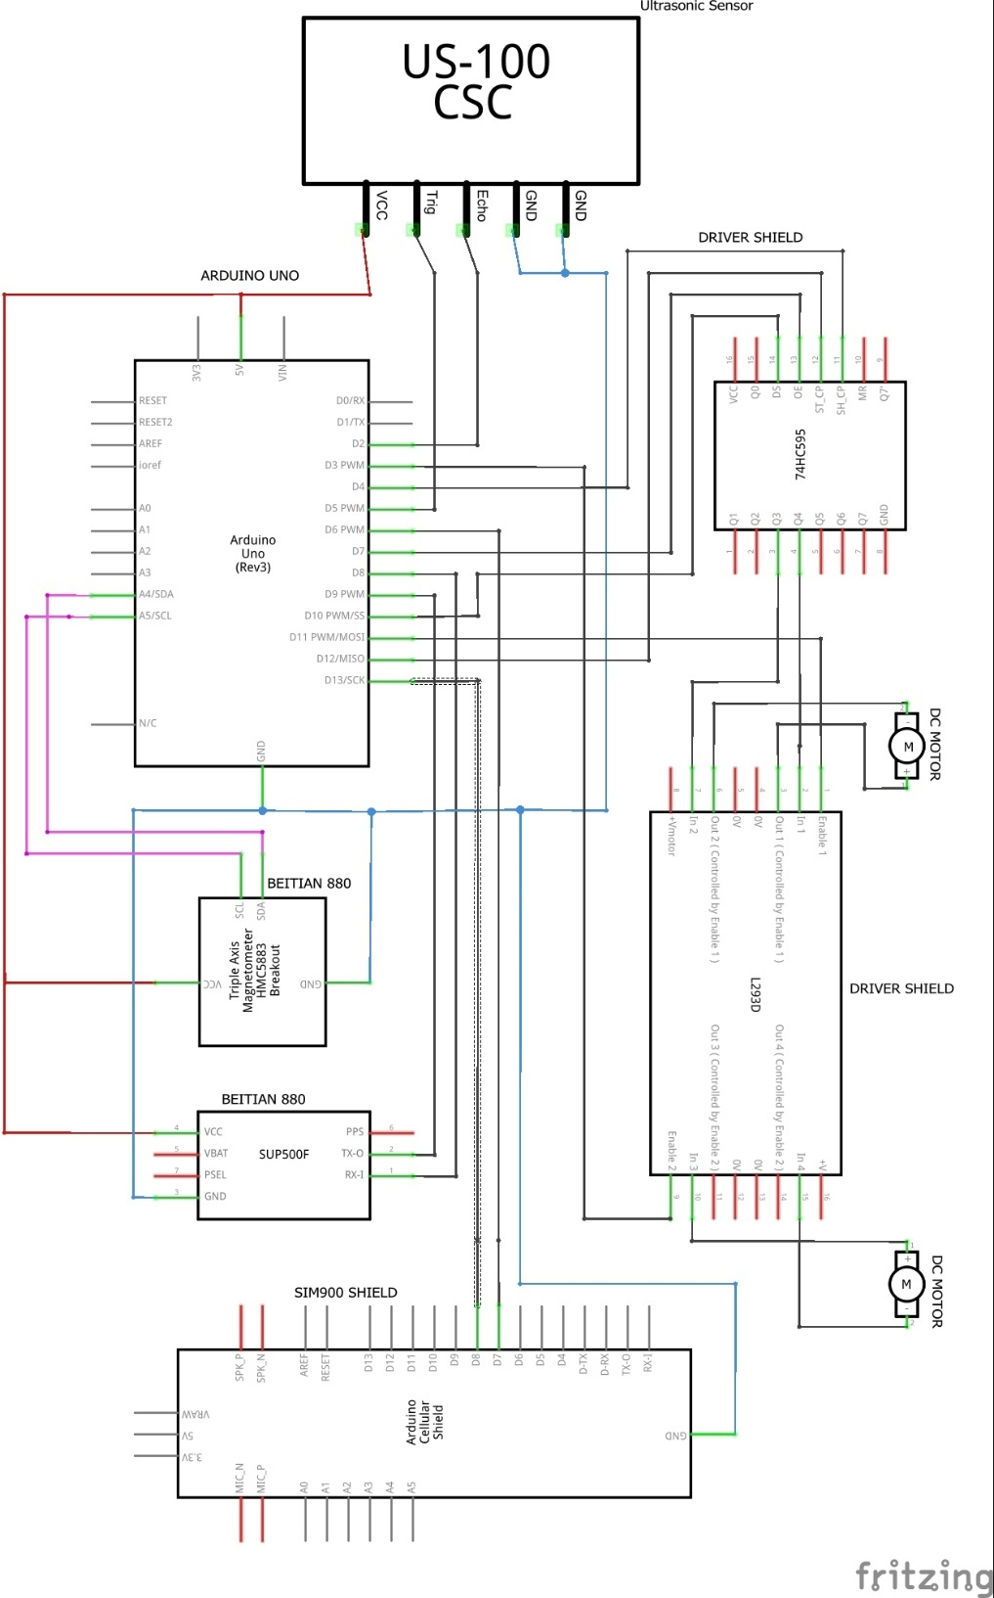

Figure 4.‎IV.6 Wiring Diagram

Figure 4.6 shows several components that used in the prototype system: Arduino Uno, US-100 Ultrasonic Sensor, SIM900 GSM Shield, Beitian BN-880 GPS, L293D Motor Driver Shield, and two DC motors. The Beitian BN-880 GPS contains two modules: triple axis magnetometer HMC583L as the compass and a GPS module. The L293D Motor Driver Shield contains two modules: L293D Motor Driver Module and 74HC595 Shift Register Module.

## Entity Relationship Diagram

The entity relationship diagram (ERD) shows the entities (tables) AND the relationship between tables within the database. The Figure 4.7 shows the entity relationship diagram of the application system that will be used in this thesis.

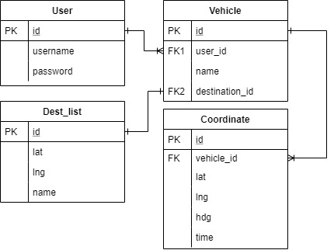

Figure 4.‎IV.7 Entity Relationship Diagram

There are four tables in the database: *user*, *vehicle*, *coordinate*, and *dest_list*. The table *user* is used to store all of the user that can login to the application. This table has three columns: *id* (PK), *username* and *password* where *id* is the primary key. The table *vehicle* is used to store vehicle (prototype). It has four columns: *id* (PK), *user_id,* *name,* and *destination_id*. Each vehicle is owned/operated by a user and has a destination. The table *coordinate* is used to store all of the past coordinate data of the vehicle. This table has six columns: *id* (PK), *vehicle*_*id*, *lat*, *lng*, *hdg*, and *time*. The table *dest_list* is used to store all of destination of the prototype. It has four columns: *id* (PK), *lat*, *lng*, and *name*.

# SYSTEM IMPLEMENTATION

This chapter describe the implementation of vehicle prototype and web application. The development of an autonomous apron vehicle prototype uses C as the programming language and Arduino IDE as the environment. While the tracking and monitoring application uses Php programming language as the backend development, and Javascript programming language as the frontend development. This chapter contains two parts: User Interface (UI) Development and Prototype System Details. The UI Development covers the user interface of the web application, while the Prototype System Details explains the implementation of the code inside the system.

## User Interface Development

This section includes web application design and guidance. The system's web application includes two pages: Login Page and Tracking and Monitoring (Map) Page. There are three panels in the sidebar on Map Page: Set Destination, Playback Generator, and User Account.

### Login Page Interface

The Login Page is the page that appears when the user opens the application for the first time. The user must input a valid username and password to log into the application. This page has two text inputs that accept username and password and a button to log into the application. Figure 5.1 below shows the interface of this page.

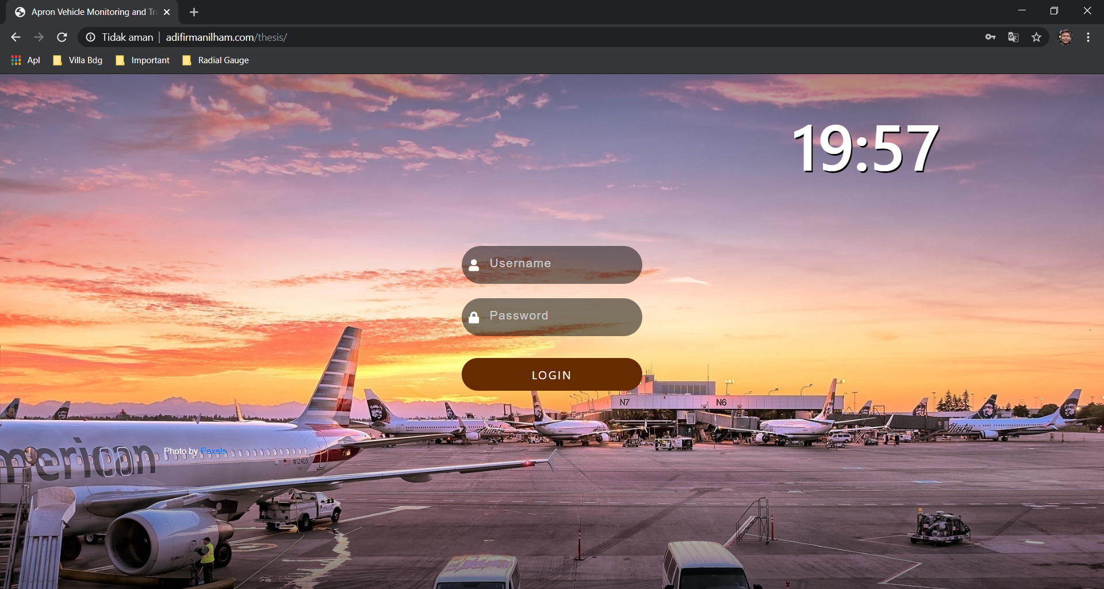

Figure 5.1 Home Page Interface [34]

### Tracking and Monitoring Page Interface

The Tracking and Monitoring (Map) Page is the page that contains all of the information of the apron vehicle prototype. This page displays a full-screen map, zoom tools at the top left corner, and a sidebar at the right. This page also displays the location of two markers that considered as destinations and a yellow triangle icon that represents the latest location of the prototype. The user can click the marker to display the destination name. The user can also click the vehicle prototype icon to display the vehicle data such as name, last update, latitude, longitude, and heading. Figure 5.2 below shows the interface of the map page.

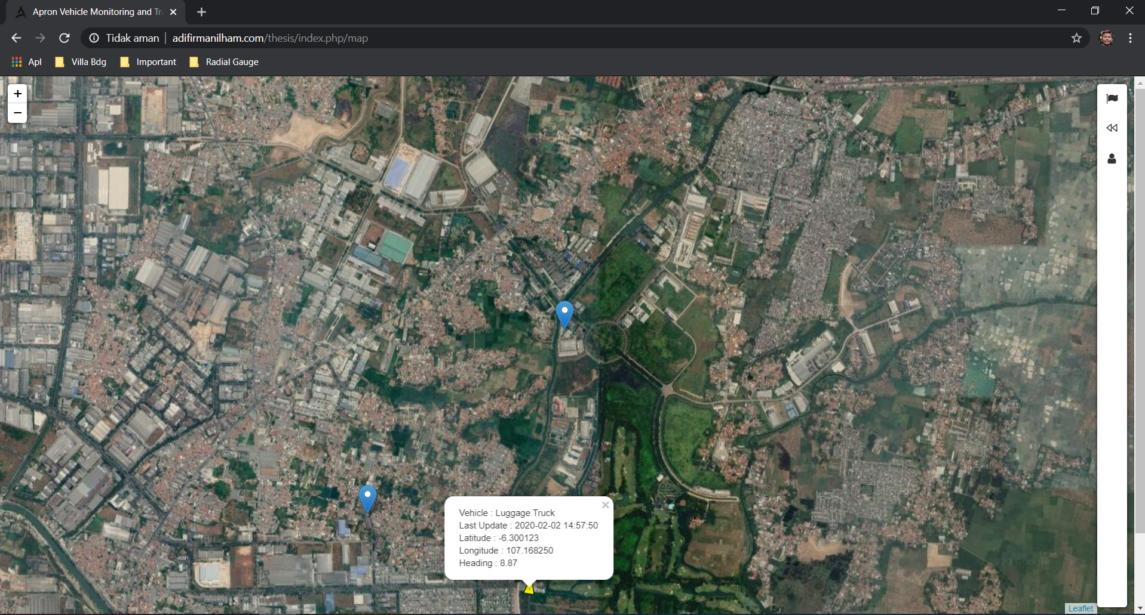

Figure 5.2 Tracking and Monitoring Page

### Set Destination Panel Interface

The Set Destination Panel is one of the panels on the sidebar. This panel contains a combo box that allows the user to select the destination of the prototype. It also has a button to set the new destination. Figure 5.3 below shows the interface of the panel.

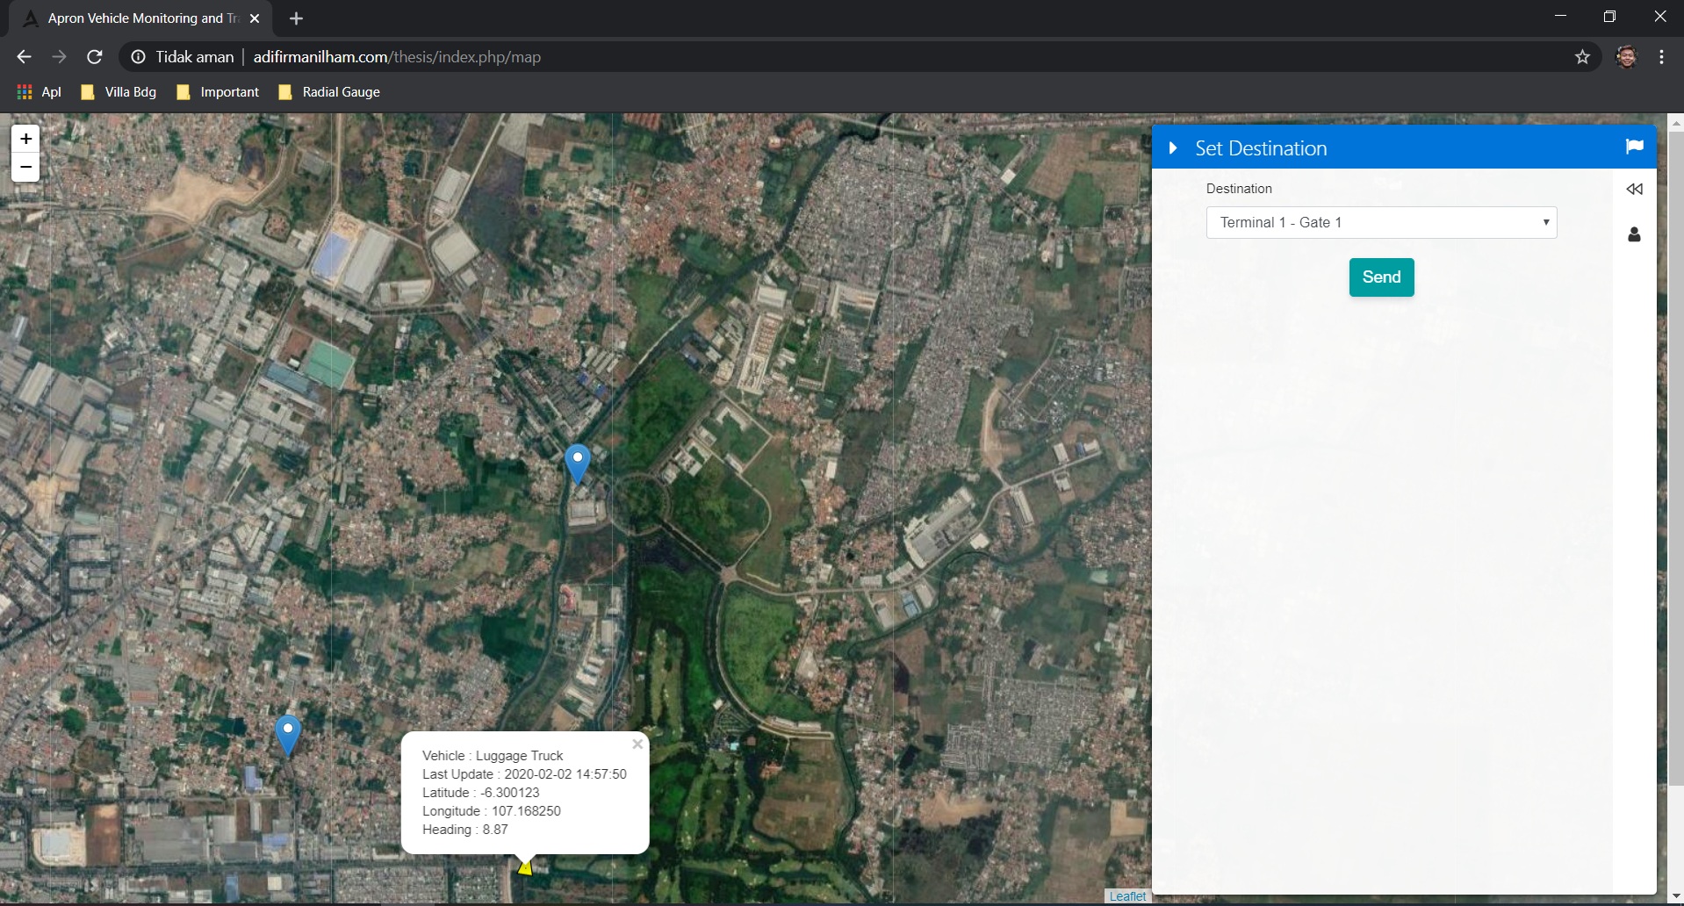

Figure 5.3 Set Destination Panel

### Track Prototype Movement Panel Interface

The Prototype Movement Panel is one of the panels on the sidebar. This panel contains two text inputs that allow the user to pick the date and time and a button to generate the playback. The first text input allows the user to select the starting date and time while the second text input allows the user to select the finishing date and time. Figure 5.4 below shows the interface of the panel.

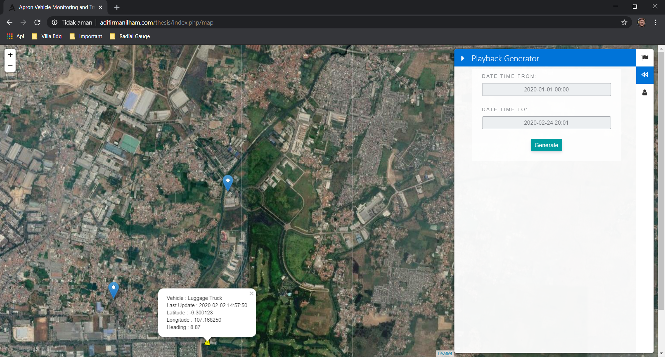

Figure 5.4 The Prototype Movement Panel

After selecting the starting and finishing date and clicking Generate Button, the application will display the playback interface to animate the movmenet of the prototype. The playback interface is a track, a vehicle icon, and a control bar that allows the user to play, pause, slow down, and speed up the animation. Figure 5.5 below shows the interface of the playback.

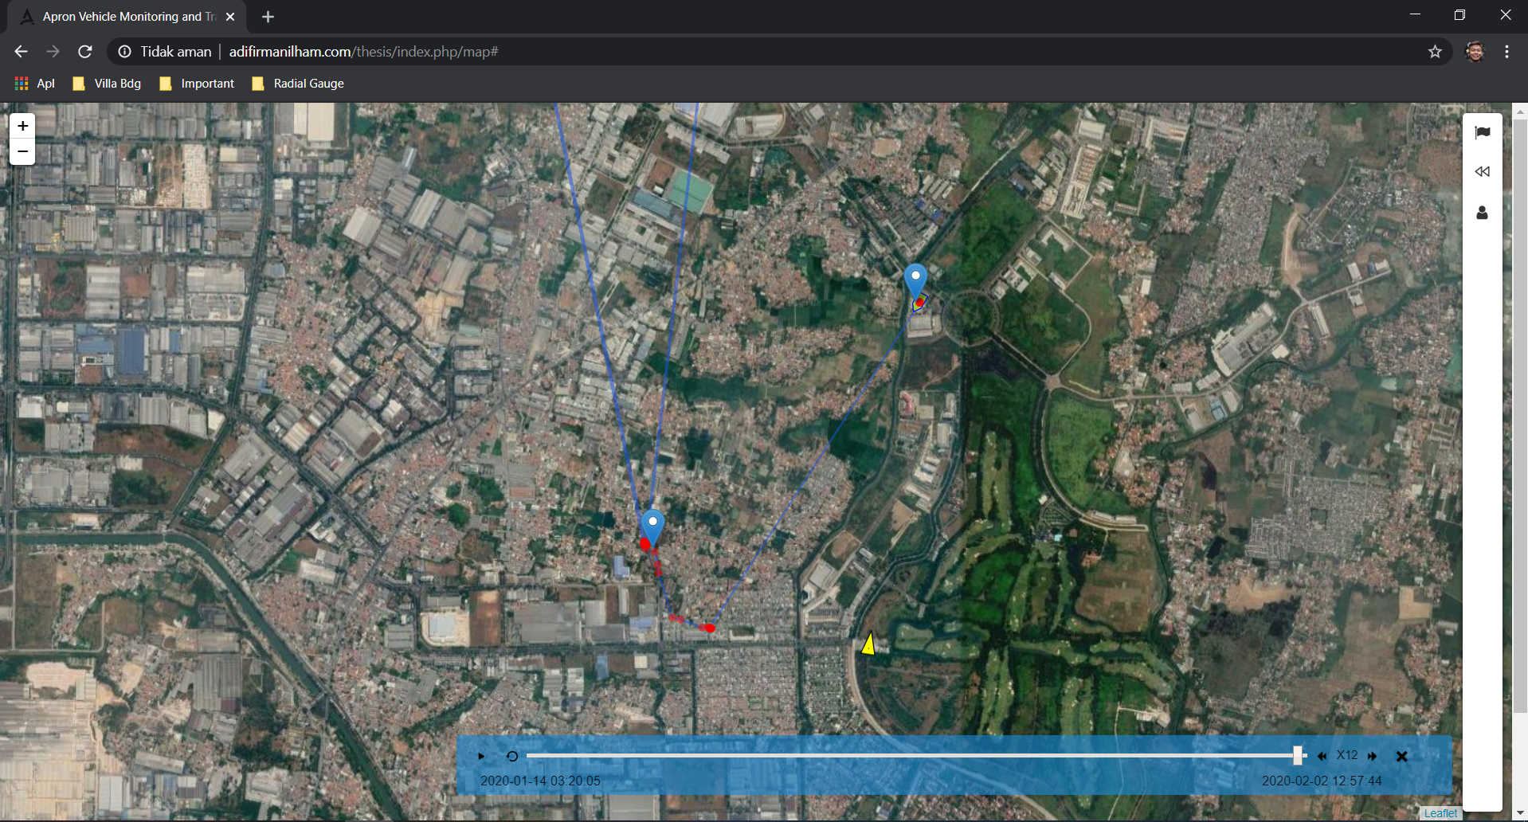

Figure 5.5 Playback Interface

### User Account Interface

The User Account Panel is one of the panels on the sidebar. This panel contains a button that allows the user to log out from the application. Figure 5.6 below shows the interface of this panel.

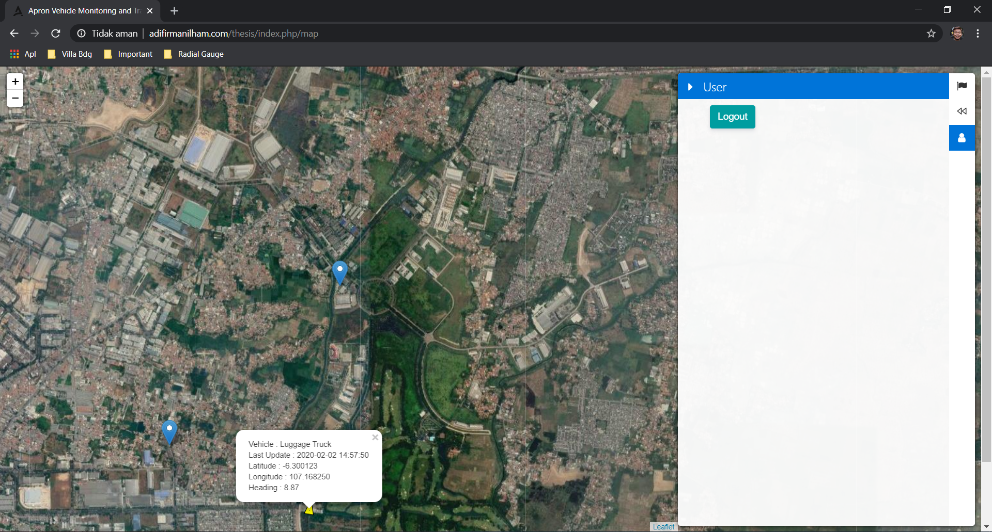

Figure 5.6 User Account Panel

## Application Details

Application Details describes how the code behind the feature of the web application and the prototype. There are two details of the code: web application side and autonomous vehicle prototype side.

### Monitor Prototype

This section explains the process of monitoring prototype. This section consists of getting the latest position of the prototype and displaying it into the map. Figure 5.7 below shows the code of getting the latest position of the prototype.

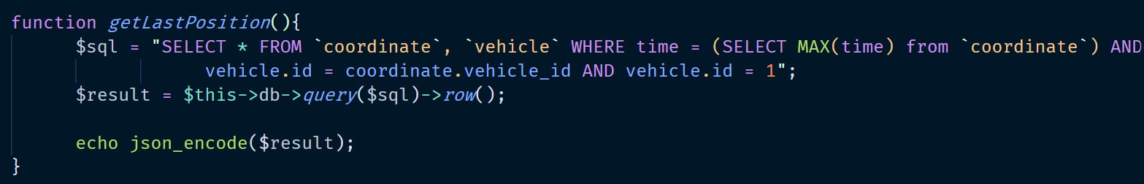

Figure 5.7 Get the Latest Prototype Position

The function *getLastPosition()* obtains the data from table *coordinate* and table *vehicle*. The latest data from table *coordinate* that will be displayed are latitude, longitude, heading and time stamp, while the data from table *vehicle* is vehicle name. This function runs in the server side and returns the result to the client side as JSON. Figure 5.8 and 5.9 below show the code that retrieves the data from the function above.

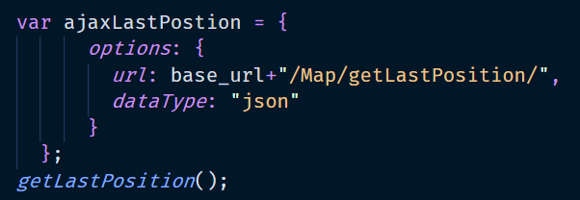

Figure 5.8 AJAX Variable to Obtain Prototype Information and Coordinate

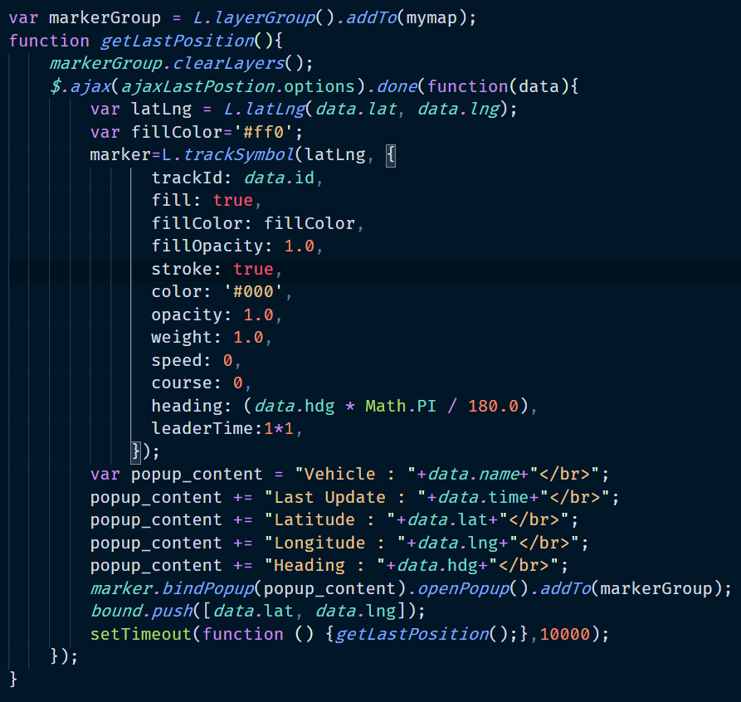

Figure 5.9 Display Prototype Information Code

The Figure 5.8 shows the AJAX variable to get the vehicle coordinate data from the server-side. The Figure 5.9 is the function to display the data. The latest vehicle position is displayed on the map as a marker. The vehicle information that displayed as a popup window that appears when the user clicks the vehicle icon. The popup window contains the following information: vehicle name, vehicle last update, vehicle latitude, vehicle longitude, and vehicle heading. The function updates the information by calling itself every 10 seconds.

### Set Destination

This section explains the process of setting up the destination. This section consists setting up the destination based on user selection and print it into a page. The figure below shows the code of setting up the destination based on user selection.

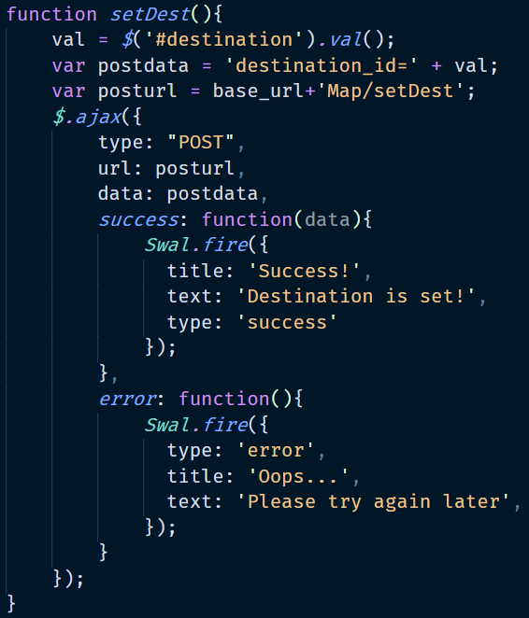

Figure 5.10 Set Destination Client-side Code

The function *setDest()* above runs in the client-side to retrieve the destination ID selected by user. The value will be sent to the server-side by using AJAX. Figure 5.11 below shows the code of the server-side function.

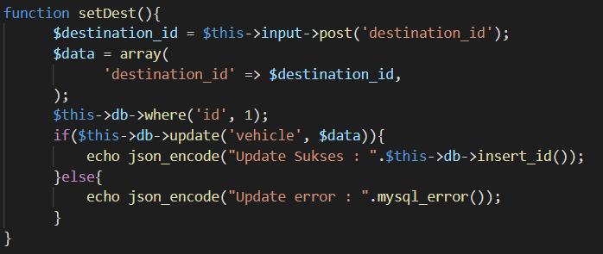

Figure 5.11 Set Destination Server-side Code

The function *setDest()* above runs in the server-side to retrieve the destination ID and updates the table *vehicle* where it stores the current destination of each vehicle. The new destination is printed in the Destination Page which the prototype will visit this page to read the destination. Figure 5.12 below shows the code of the Destination Page.

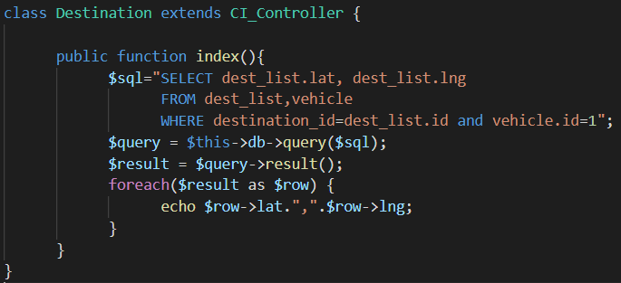

Figure 5.12 Print Destination in the Destination Page Code

The function *index()* above obtains the data from two tables: *dest_list* and *vehicle*. This function prints the latitude and longitude of current destination of certain vehicle.

### Track Prototype Movement

This section explains the process of tracking prototype movement. The tracking prototype movement is displayed on the map as a playback. This section consists of getting the range of playback data and displaying it into the map. The figure below shows the code of getting the range of playback data.

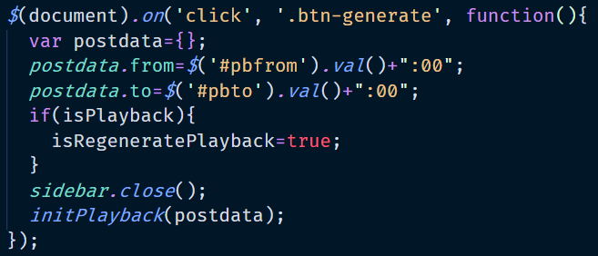

Figure 5.13 Get Playback Range Code

The function above runs in the client-side to retrieve the value of the starting date time and the finishing date time to display prototype movement. Those values are sent as the object to a function *initPlayback()* as shown below.

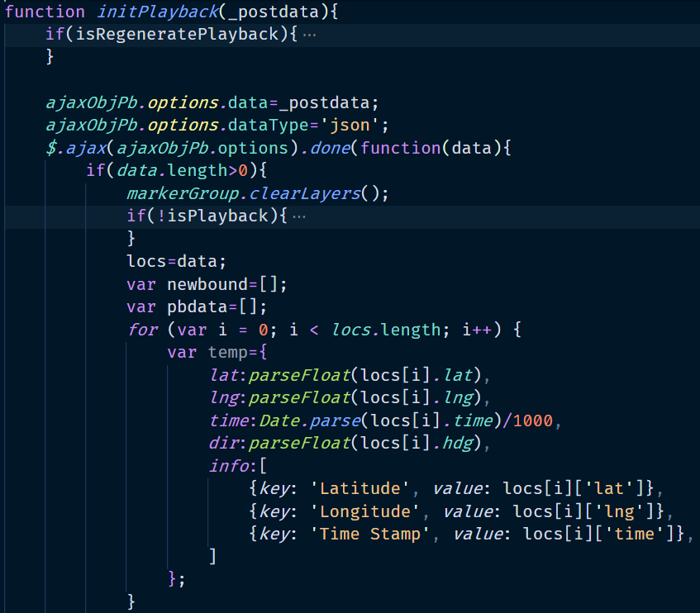

Figure 5.14 Initializing Playback Code

The function initPlayback() takes the starting and finishing date value and assign them to become *ajaxObjPb* attribute values. The figure below shows the AJAX variable *ajaxObjPb*.

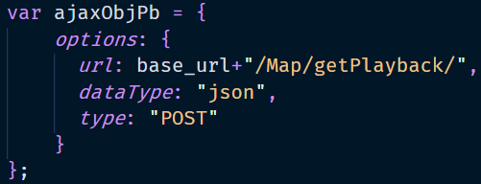

Figure 5.15 AJAX Get Playback Code

The variable *ajaxObjPb* retrieves the data from the server-side. The response data are: latitude, longitude, date, and heading. The AJAX variable above sent the data to a function *getPlayback()* as shown below.

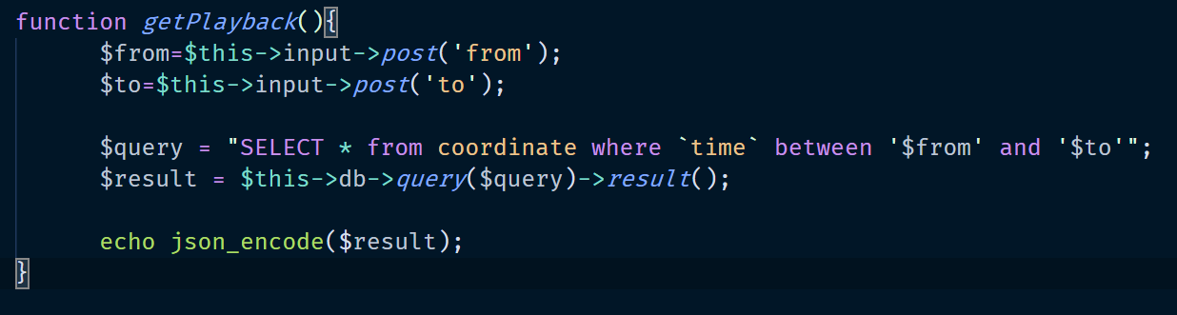

Figure 5.16 Get Playback Server-side Code

The function *getPlayback()* above runs in the server-side to retrieve playback data between a determined starting and finishing date. This function returns the data to the client side as JSON. The return data is used to draw the playback. Figure 5.17 below shows the code to display it on the map.

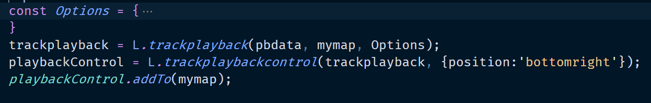

Figure 5.17 Display Playback Code

Figure above shows two main components of the playback. The first part is *trackplayback*. *Trackplayback* is the drawn path on the map. The path is drawn based on the past latitudes and longitudes of the prototype. The second part is playback control. Playback control is the toolbar that provides several controls for the playback such as play, stop, fast reverse and fast forward the animation.

### Move to the Destination

This section explains how the prototype move towards the destination. First, the prototype reads the destination and obtains its current coordinate (latitude and longitude) and heading. The prototype then calculates the distance and heading to the destination by using its coordinate value and destination coordinate value. Next, the prototype start moving. It always adjusts its heading to the destination. The steps above are done repeatedly until it arrives at the destination.

* **Read the Destination**

This section explains the process of how the prototype reads the destination. The prototype uses SIM900 GSM module to perform GSM internet connection to visit a URL to obtain the destination. The destination is stored in the system for further movement calculation. Figure 5.18 shows the process of initializing SIM900 GSM module and read the destination from a URL.

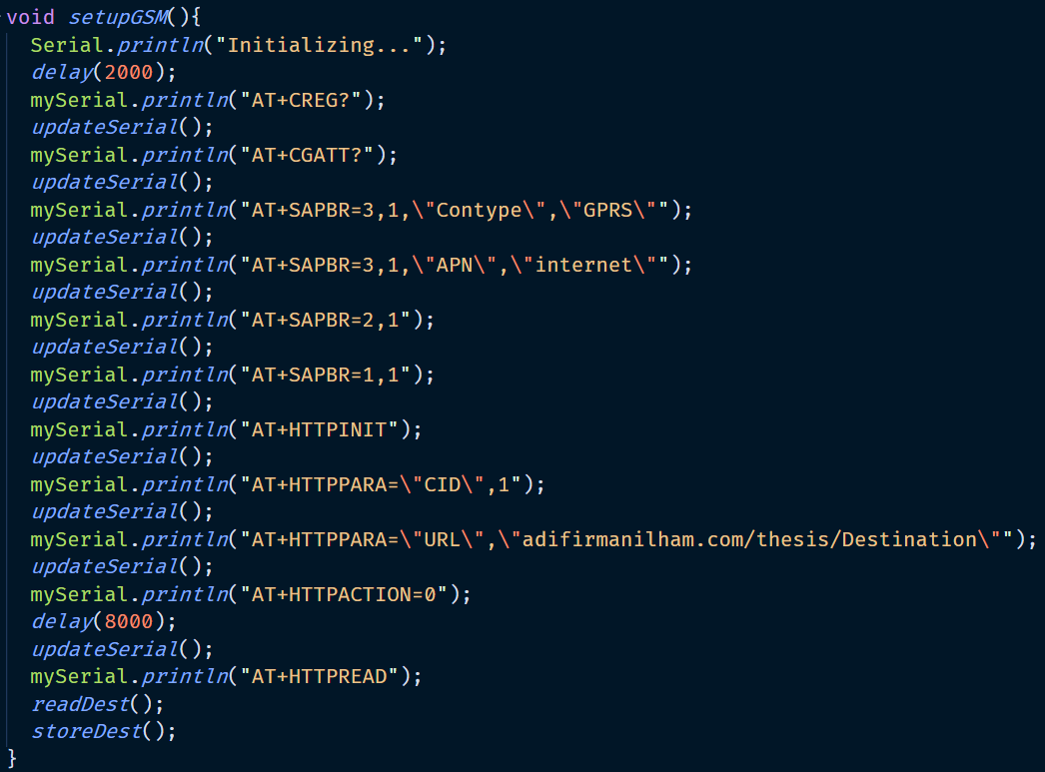

Figure 5.18 Initializing SIM900 GSM Module and Read the Destination Code

The function setupGSM() above prepares the GPRS connection first and then starts the HTTP read. The system visits a URL to read the destination. The destination is taken from the URL *adifirmanilham.com/thesis/Destination/* as shown in Figure 5.19 below.

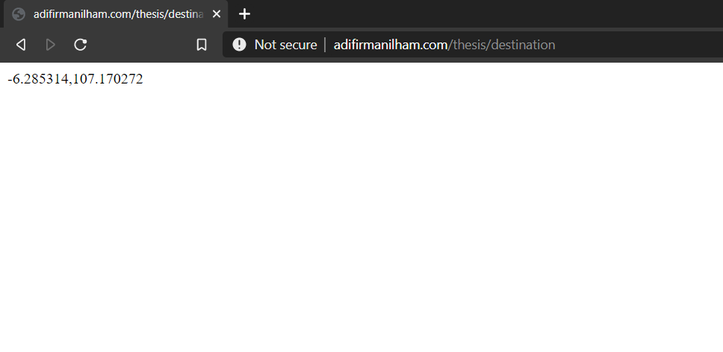

Figure 5.19 URL to Read the Destination

The system visits above url and get the return data. The complete return data is shown in the Figure 5.20 below.

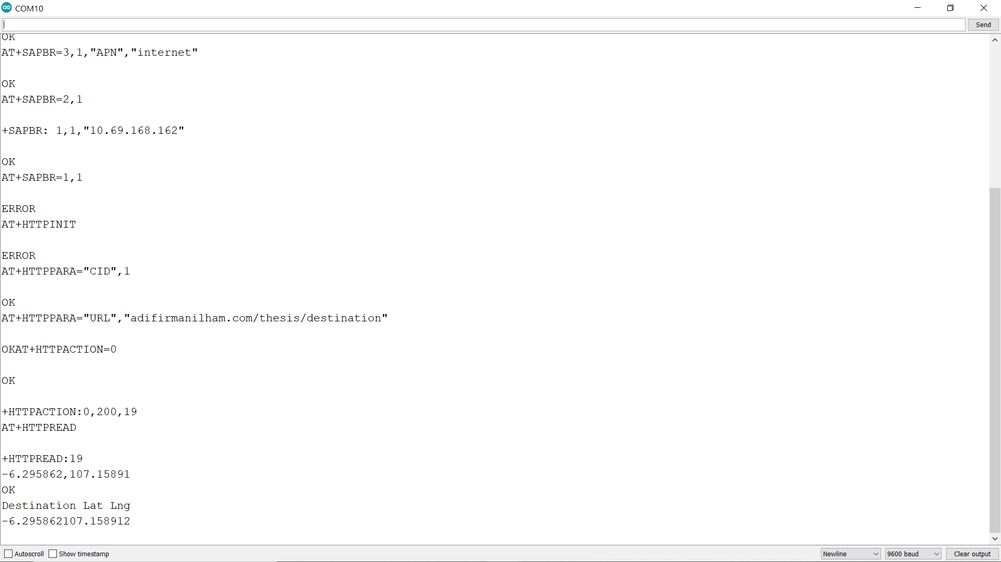

Figure 5.20 Complete Return Data

The data above contains not only latitude and longitude but also the HTTP status. The system breaks down the data above into a char in order to get the latitude and longitude only. Figure 5.21 below shows the code of breaking down the return data.

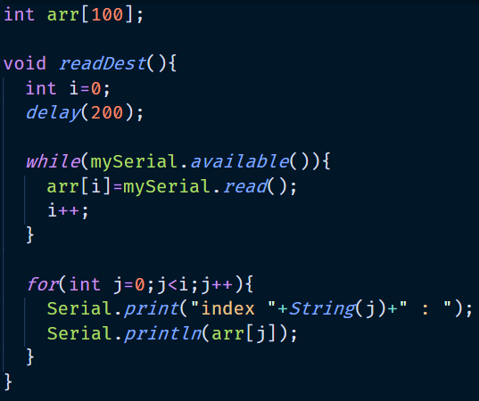

Figure 5.21 Breaking Down the Return Data Code

The function *readDest()* above stores each element of the return data into array *arr*. The system then prints the value of each index of array *arr*. The figure below shows the value of each index in the array *arr*.

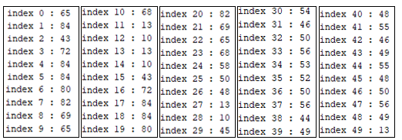

Figure 5.22 Value of Each Index of Array *Arr*

The system gets the ascii value of each index. The ascii value then converted into char as shown in Figure 5.23 below.

|  |  |  |  |  |  |  |  |  |  |  |  |
| --- | --- | --- | --- | --- | --- | --- | --- | --- | --- | --- | --- |
| Index | 0 | 1 | 2 | 3 | 4 | 5 | 6 | 7 | 8 | 9 | 10 |
| ASCII num | 65 | 84 | 43 | 72 | 84 | 84 | 80 | 82 | 69 | 65 | 68 |
| Char | A | T | + | H | T | T | P | R | E | A | D |

|  |  |  |  |  |
| --- | --- | --- | --- | --- |
| Index | 11 | 12 | 13 | 14 |
| ASCII num | 13 | 10 | 13 | 10 |
| Char | CR | LF | CR | LF |

|  |  |  |  |  |  |  |  |  |  |  |  |  |
| --- | --- | --- | --- | --- | --- | --- | --- | --- | --- | --- | --- | --- |
| Index | 15 | 16 | 17 | 18 | 19 | 20 | 21 | 22 | 23 | 24 | 25 | 26 |
| ASCII num | 43 | 72 | 84 | 84 | 80 | 82 | 69 | 65 | 68 | 58 | 49 | 57 |
| Char | + | H | T | T | P | R | E | A | D | : | 1 | 9 |

|  |  |  |
| --- | --- | --- |
| Index | 27 | 28 |
| ASCII num | 13 | 10 |
| Char | CR | LF |

|  |  |  |  |  |  |  |  |  |  |  |
| --- | --- | --- | --- | --- | --- | --- | --- | --- | --- | --- |
| Index | 29 | 30 | 31 | 32 | 33 | 34 | 35 | 36 | 37 | 38 |
| ASCII num | 45 | 54 | 46 | 50 | 57 | 53 | 56 | 54 | 50 | 44 |
| Char | - | 6 | . | 2 | 9 | 5 | 8 | 6 | 2 | , |

|  |  |  |  |  |  |  |  |  |  |  |
| --- | --- | --- | --- | --- | --- | --- | --- | --- | --- | --- |
| Index | 39 | 40 | 41 | 42 | 43 | 44 | 45 | 46 | 47 | 48 |
| ASCII num | 49 | 48 | 55 | 46 | 49 | 53 | 56 | 57 | 49 | 48 |
| Char | 1 | 0 | 7 | . | 1 | 5 | 8 | 9 | 1 | 0 |

Figure 5.‎V.23 Conversion from ASCII to Char

From figure above, the latitude value is located in the index 29 to 37 while the longitude value is located in the index 39 to 48. Figure 5.24 below shows the code to store the latitude and longitude.

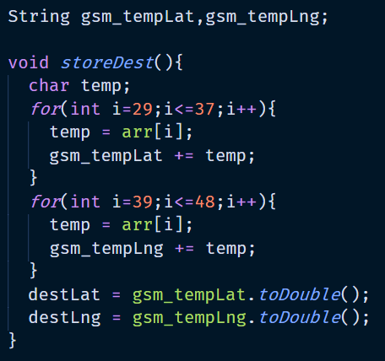

Figure 5.24 Store Latitude and Longitude Code

The function *storeDest()* above reads the value from index 29 to 37 of array *arr*. Those values are converted into double and stored in variable *destLat*. The value from index 39 to 48 in the array *arr* are converted also into double and stored in variable *destLng*.

* **Get Current Coordinate and Heading**

Figure 5.25 below shows the necessary library and global variable to get current coordinate.

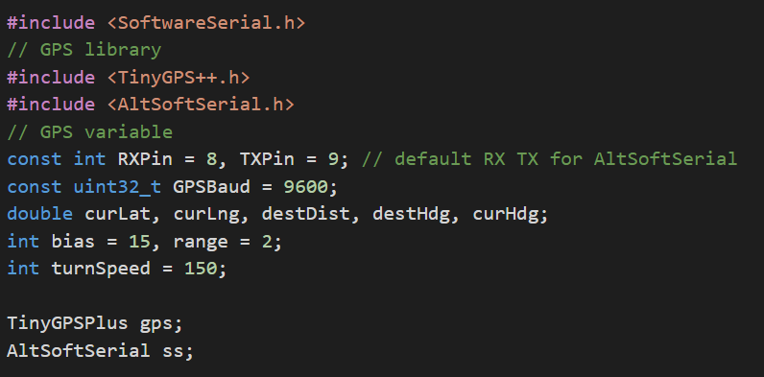

Figure 5.25 GPS Library and Global Variables

The system uses TinyGPS++ library and AltSoftSerial library to determine the value of current coordinate and heading. Those values are stored in the global variable. The variable *curLat*, *curLng* and *curHdg* stores the values of current latitude, longitude, and heading respectively. The variable *destDist* and *destHdg* stores the value of distance to the destination and heading to the destination respectively. The variable *bias* is used to create heading range to the destination. The value of *bias* is 15 meaning that the tolerance angle of heading to the destination is 30 degree, starting from 15 degree to the left of *curHdg* until 15 degree to the right of *curHdg*. The variable *range* used to create the distance tolerance from the destination. The value of range is 2 meaning the tolerance distance to the destination is 2 meters. So, when the prototype is 2 meters away from the destination it is considered to have arrived at the destination.

Figure 5.26 below shows the code of getting current coordinate.

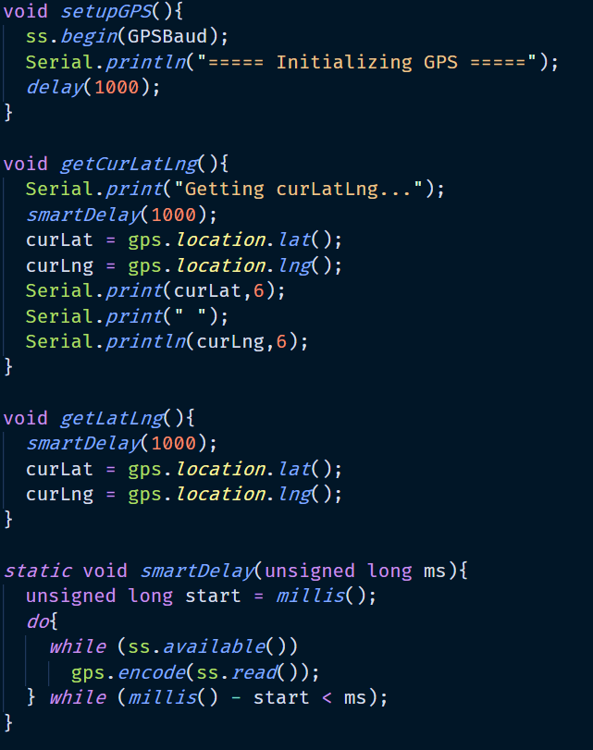

Figure 5.26 Get Current Latitude and Longitude

The function *setupGPS()* initialize the communication with the GPS module. The function *getCurLatLng()* is used to determine current coordinate by using function *smartDelay()* to encode GPS data and *gps.location.lat()* and *gps.location.lng()* in getting the latitude and longitude. The GPS encoding is done by using the built-in function from TinyGPS++ library.

Figure 5.27 shows the code of getting current heading.

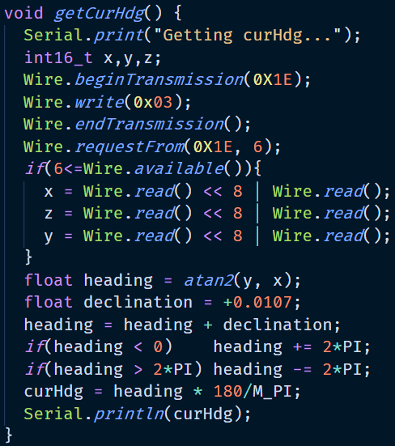

Figure 5.27 Get Current Heading

The function *getCurHdg()* initializes the communication with compass module and obtains the magnetic value of each axes: x, y, and z. The magnetic heading is obtained by calculating the invers tan of y and x value ${(tan}^{-1}{\frac{y}{x}})$. The value of magnetic heading must be adjusted using the declination angle to produce the true heading. The true heading then must be validated if it produces the invalid value and finally must be converted into degree.

* **Calculate Distance and Heading to the Destination**

Figure 5.28 below shows the code of getting heading and distance to the destination.

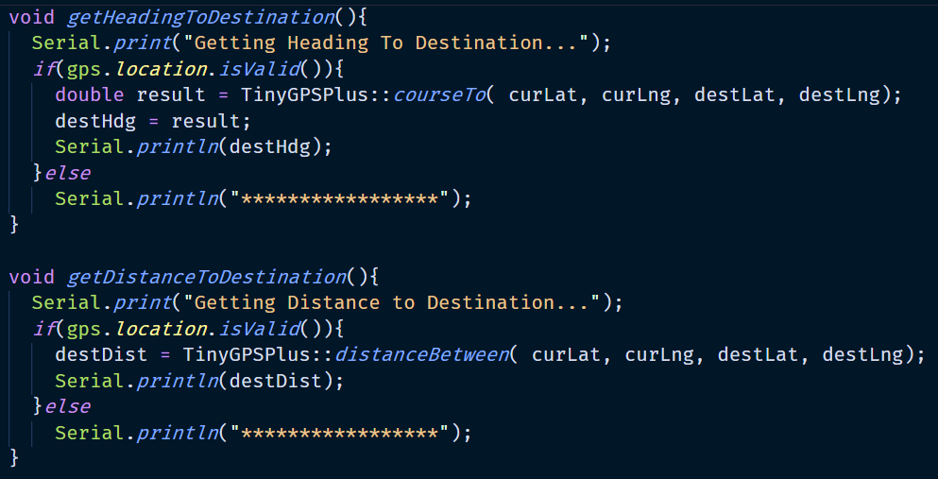

Figure 5.28 Get Heading and Distance to Destination Code

The function *getHeadingToDestination()* validates the GPS coordinate value first. It calculates the heading to the destination by using the built-in function *courseTo()* from the TinyGPS++ libray. The value of the heading is stored in the variable *destHdg*.

The function *getDistanceToDestination()* validates the GPS coordinate value first. It calculates the distance to the destination by using the built-in function *distanceBetween()* from the TinyGPS++ libray. The value of the destination is stored in variable *destDist*.

* **Adjust Heading**

This section explains how the prototype adjust its heading that keeps the prototype stay inside tolerated angle when moving towards the destination. Figure 5.29 below show the code to get necessary value to adjust heading.

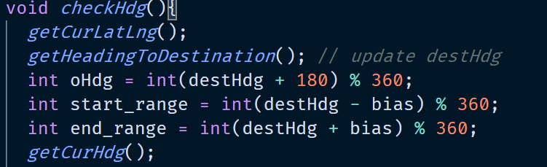

Figure 5.29 Getting Values to Adjust Heading

The figure above obtains the latest current latitude, longitude, heading to the destination, and current heading of the prototype. There are three variables declared in the beginning: *oHdg*, start_*range*, and end_*range*. Variable *oHdg* is the opposite heading of the destination heading. Variable *start*_range and *end_range* determines the range of tolerated heading value.

Figure 5.30 below shows the right-side angle checking process. It uses variable *oHdg* as the first angle (A) and variable *start_range* as the second angle (B).

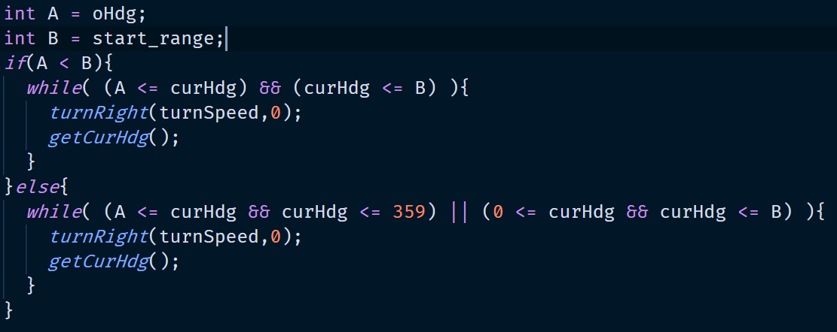

Figure 5.30 Left-side Angle Checking Process

When the current heading of the prototype is between A and B, it means the vehicle is out of the heading range and it must turn right until it gets into the tolerated heading range.

Figure 5.31 below shows the right-side angle checking process. It uses variable *end_range* as the first angle (A) and variable *oHdg* as the second angle (B).

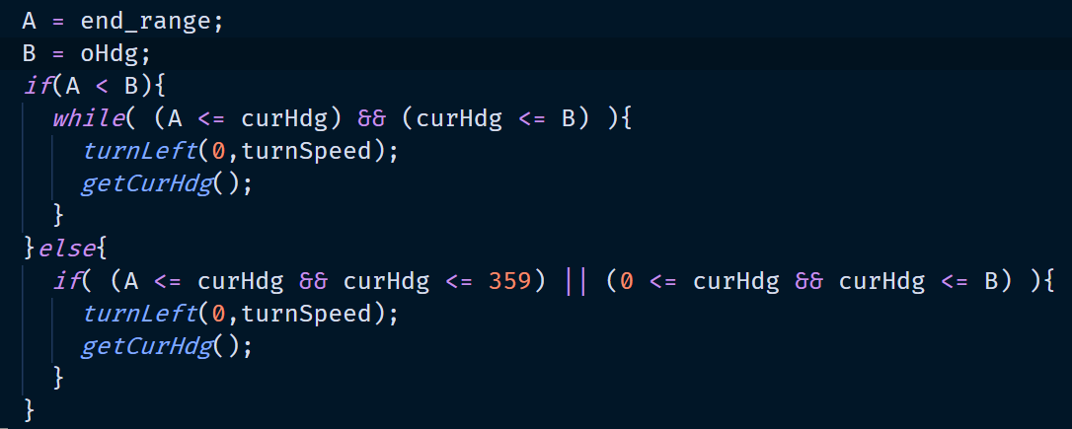

Figure 5.31 Right-side Angle Checking Process

When the current heading of the prototype is between A and B, it means the vehicle is out of the heading range and it must turn left until it gets into the tolerated heading range.

* **Move Towards Destination**

This section explains how the prototype move towards the destination. Figure 5.32 below shows the code to declare the necessary global variables to perform the movements.

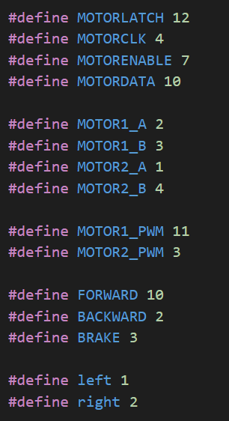

Figure 5.32 Global Variable Declaration to Perform Movement

The figure above contains several global variables. The variable *MOTORLATCH*, *MOTORCLK*, *MOTORENABLE*, and *MOTORDATA* are used to enable and communicate with the 74HC595 Shift Register. The numbers next to those variables are pin used in the Arduino. The variable *MOTOR1_A*, *MOTOR1_B*, *MOTOR2_A*, and *MOTOR2_B* are used to control the direction of the two DC motors. The numbers next to those variables are pin used in the 74HC595 Shift Register. The variable *MOTOR1_PWM* and *MOTOR2_PWM* are used to control the speed of the motors respectively. The number next to those variables are pin used in the Arduino. The last variable *FORWARD*, *BACKWARD*, *BRAKE*, *left*, and *right* are used to control the direction of the prototype. Figure 5.33 below shows the code to control the movement of the prototype.

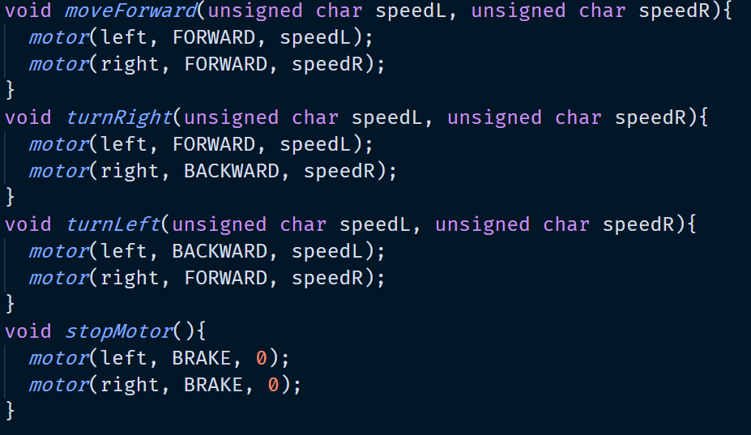

Figure 5.33 Movement Control Code

Those function in figure above determines the available movement of the prototype: move forward, turn right, turn left, and stop. Each function call other two functions *motor()* to control the speed and the direction of the left and right motor.

Figure 5.34 below shows the code to control speed and the direction of a motor.

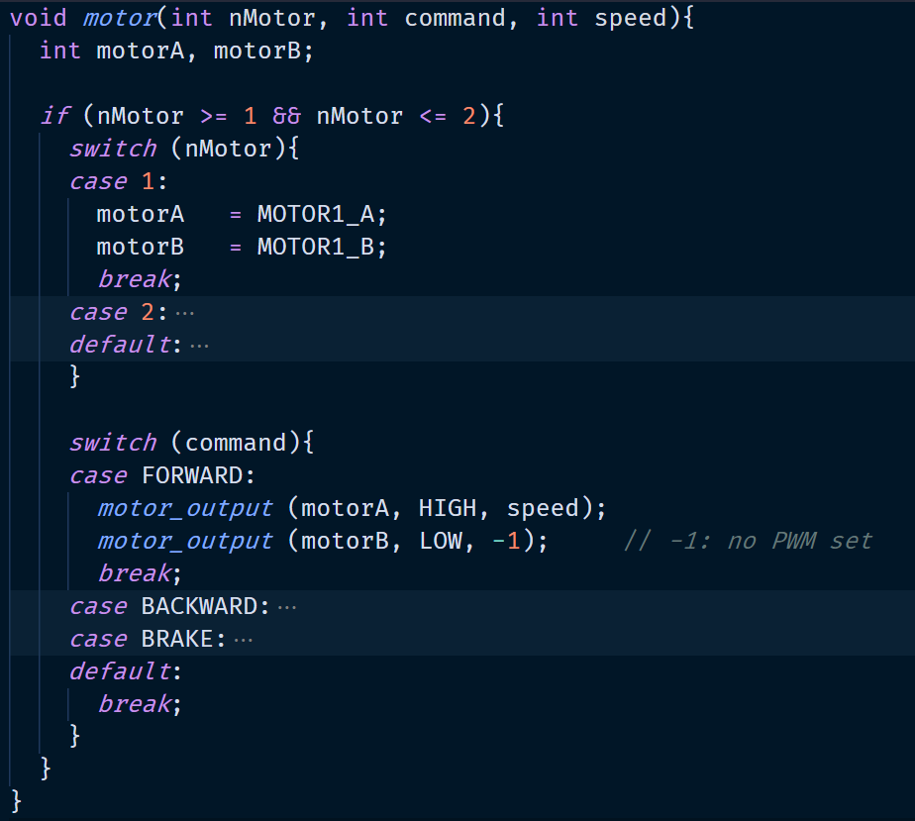

Figure 5.34 Speed and Direction Control Code

The function *motor()* above filters which motor to be processed based on the direction command. The filtered value are then to be sent based on the direction to two other functions *motor_output()* to implement speed and movement. Figure 5.35 below shows the code of implementing speed and movement.

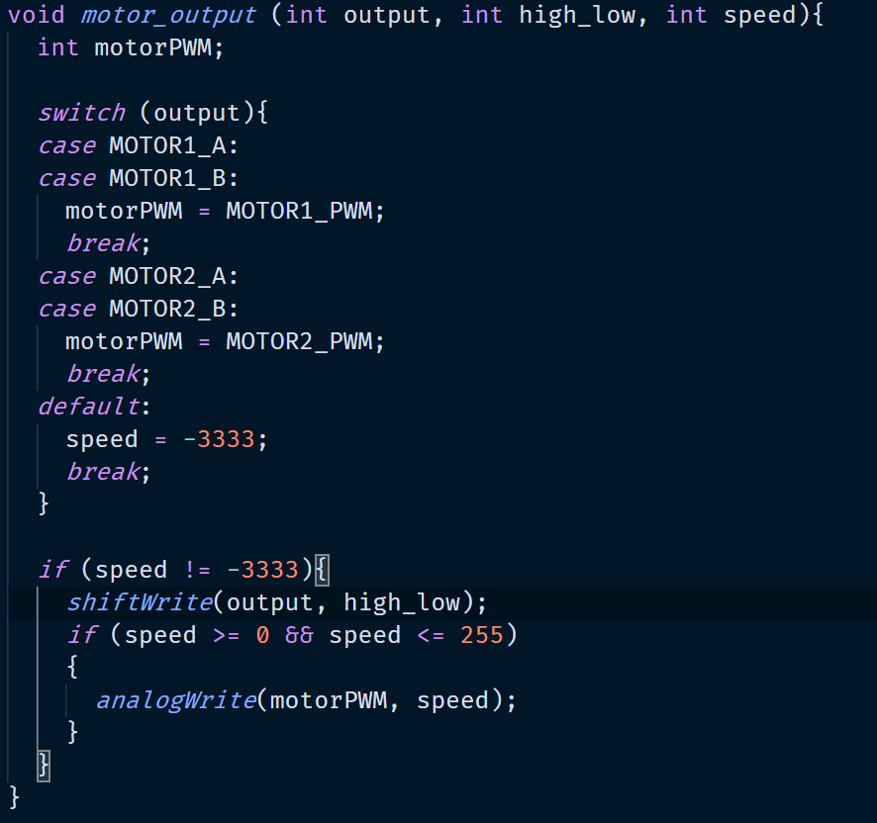

Figure 5.35 Speed and Movement Code

The *motor_output()* function above filters the motor position (left and right motor) and implements the speed of the corresponding motor using *analogWrite()* function. It implements the direction of the motor by using *shiftWrite()* function.

* Arrive at the destination

Figure 5.36 below shows the code to determine if the prototype arrives at the destination.

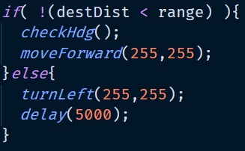

Figure 5.36 Arrive at The Destination Code

The codes above compare the distance to the destination with variable range. When the distance to the destination is greater or equal than range, the prototype adjusts its heading and move forward toward the destination. When the distance to the destination is less than equal range, the prototype is considered to have arrived at the destination. The prototype performs left spinning to indicate that it has arrived at the destination.

### Avoid Obstacle

This section explains how the prototype avoid hitting the obstacle in front of it. Figure 5.37 below shows the code to declare the necessary global variables to perform avoiding obstacle.

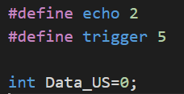

Figure 5.37 Global Variable to Perform Avoid Obstacle Code

The system uses pin 2 and 9 as the echo and trigger of the US-100 Ultrasonic Sensor Module respectively. It stores the value of the distance between the prototype and obstacle in front of it inside variable *Data_US*.

Figure below shows the code of initializing US-100 module and reading the obstacle distance.

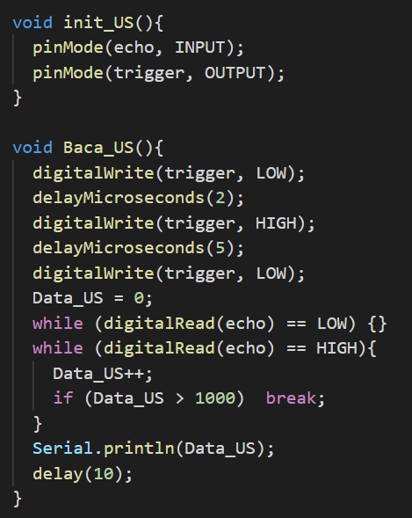

Figure 5.38 Initializing US-100 Ultrasonic Sensor Module and Read Obstacle Distance Code

The function *init_US()*configures the pins used by the module. The function *Baca_US()* generate ultrasound by setting the trigger pin to high and will be received by the echo pin. This function obtains the distance between the prototype and the object in front of it by reading echo using *digitalRead()* function. The distance is stored in the variable *Data_US*. The *Data_US* variable is used to avoid hitting the obstacle. Figure 5.39 below is the code to avoid hitting the obstacle.

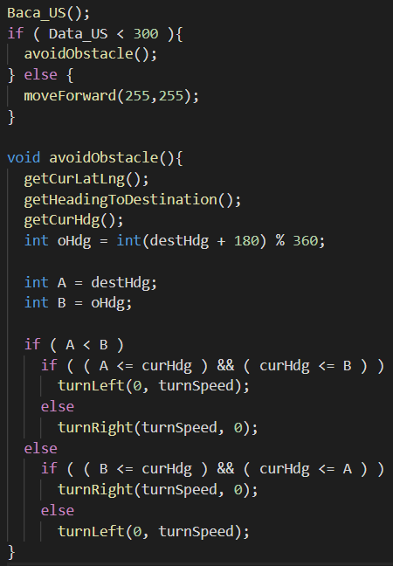

Figure 5.39 Avoid Obstacle Code

When the obstacle distance is less than 30 cm, the prototype calls function *avoidObstacle()* to determine whether the prototype turns left or right to avoid hitting the obstacle. Fugre xx below shows the code of function *avoidObstacle().*



Figure 5.40 Avoid Obstacle Code Part 2

The prototype movements depends on its current heading. If the current heading *curHdg* is to the left of the heading to the destination *destHdg*, then it turns right to avoid the obstacle and vice versa.

### Send Coordinate and Heading

This section explains how the prototype send coordinate and heading to the web server and how the web server stores the coordinate and heading. Figure 5.40 below shows the code of sending the coordinate using SIM900 GSM module.



Figure 5.41 Sending Coordinate and Heading Code

The system visits a URL to send the coordinate. The value that being sent is latitude, longitude, and heading. Those values are written in the parameter and sent into domain *adifirmanilham.com*, subdomain *thesis*, controller *GetGPS*, and function *getData*. Figure 5.42 below shows the code of the *getData()* in the server-side.

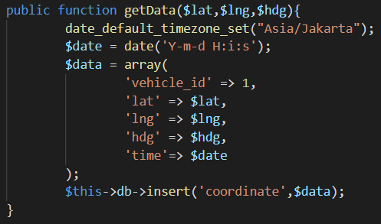

Figure 5.42 Get GPS Data Server-side Code

The function *getData()*above retrieves three parameters: latitude, longitude, and heading. Those value are then to be inserted into the table *coordinate* with other two values: *vehicle_id* and *time*.

# SYSTEM TESTING

System testing is the process to evaluate the full and implemented program. This process aims to determine if the system accomplishes the stated requirements. This chapter consists of two parts: environmental testing and scenario testing.

## Testing Environment

This testing uses the stated hardware requirement to ensure device functionality. The following are the condition requirements for this testing:

1. Internet connection is available in the application and prototype system.
2. The prototype is located at outdoor.
3. The prototype is supplied with enough power.

## Testing Scenario

This testing aims to ensure the functionality of the program and features work as expected. This testing is done by evaluating the specification of the application functionality without looking at the system code.

### User Feature Testing

This section evaluates the features that are performed by the user inside the web application with its scenario. TableI6.1 shows the user feature testing scenario.

Table 6.‎VI.1 User Feature Testing Scenario

|  |  |  |  |
| --- | --- | --- | --- |
| **Test ID** | **Scenario** | **Expected Result** | **Evaluation** |
| TESTAPP1 | Start and Login | The application opens login page and after logging in, the user is redirected to tracking and monitoring (map) page. | As Expected |
| TESTAPP2 | Monitor Prototype | The application shows the latest position of the prototype. | As Expected |
| TESTAPP3 | Set Destination | The application successfully set new destination. | As Expected |
| TESTAPP4 | Track Prototype Movement | The application successfully displays the playback of the prototype. | As Expected |
| TESTAPP5 | Logout | The user successfully logs out from the application. | As Expected |

TableI6.2 shows the test result screen capture from random scenarios in TableI6.1 as evidence that the test scenario performed as planned.

Table 6.‎VI.2 User Feature Test Result Capture Screen

|  |  |
| --- | --- |
| **Test ID** | **Result Capture Screen** |
| TESTAPP1 | Application opened as Expected:    The user logs in and directed to the tracking and monitoring (map) page: |
| TESTAPP2 | The application shows the latest position of the prototype as expected: |
| TESTAPP3 | The application successfully sets a new destination: |
| TESTAPP4 | The application displays the playback as expected: |
| TESTAPP5 | The application logs out the user as expected: |

### Prototype System Feature

This section evaluates the features that are performed inside the prototype system with its scenario. Table 6.3 shows the prototype feature testing scenario.

Table 6.‎VI.3 Prototype Feature Testing Scenario

|  |  |  |  |
| --- | --- | --- | --- |
| **Test ID** | **Scenario** | **Expected Result** | **Evaluation** |
| TESTPRO1 | Read the Destination | The prototype successfully reads the destination from the web application. | As Expected |
| TESTPRO2 | Get Current Coordinate and Heading | The prototype successfully gets the current coordinate and heading. | As Expected |
| TESTPRO3 | Get Distance and Heading to the Destination | The prototype successfully calculates the distance and heading to the destination. | As Expected |
| TESTPRO4 | Move to the Destination | The prototype successfully moves to the destination. | As Expected |
| TESTPRO5 | Avoid Obstacle | The prototype successfully reads the distance of the obstacle in front of it and avoid hitting it. | As Expected |
| TESTPRO6 | Send Current Coordinate and Heading | The prototype successfully sends the current heading and coordinate in certain period of time. | Not As Expected |
| TESTPRO7 | Avoid Obstacle and Get Current Heading and Coordinate | The prototype successfully reads the distance to the obstacle in front of it when works together with GPS. | As Expected |
| TESTPRO8 | Avoid Obstacle |  |  |

TableI6.4 shows the test result screen capture from random scenarios in table 6.3 as evidence that the test scenario performed as planned.

Table 6.‎VI.4 Prototype System Feature Result Capture Screen

|  |  |
| --- | --- |
| **Test ID** | **Result Capture Screen** |
| TESTPRO1 | Destination read as expected: |
| TESTPRO2 | Current heading and coordinate obtained as expected: |
| TESTPRO3 | Heading and distance to the destination calculated as expected: |
| TESTPRO4 | The prototype moves to the destination as expected: |
| TESTPRO5 | The distance to the obstacle obtained as expected: |
| TESTPRO6 | The coordinates and heading are not sent as expected:    The coordinates and heading transmission is performed in irregular period of time instead of regular period of time. |
| TESTPRO7 | The distance to the obstacle and coordinate are obtained as expected: |

Table 6.5 shows the testing of objects’ (obstacle) width that can be detected by the prototype.

Table ‎VI.5 Object Testing with Ultrasonic Sensor

|  |  |  |
| --- | --- | --- |
| NO | WIDTH | RESULT |
| 1. | >2cm | Fully detected |
| 2. | 0,5 - 2cm | Partially detected |
| 3. | < 0.5 cm | Fully undetected |

There are three types of the testing result: fully detected, partially detected, and fully undetected. Fully detected means that the object can be placed anywhere in front of the prototype to detect. Partially detected means that the object must be placed exactly in front of the ultrasonic sensor (at the front middle of the prototype) to detect. Fully undetected means that the prototype cannot detect the object in front of it.

# CONCLUSION AND FURTHER WORK

## Conclusion

The development of the application and prototype system in this thesis results in the following conclusions:

1. The system can increase the work efficiency and safety at the apron since it is operated autonomously; it eliminates human error and can operate 24 hours without getting fatigued.
2. The system can move towards the destination autonomously. The system performs its movement by reading the destination first. After that, it obtains the current heading and coordinates and uses them to calculate the heading and distance to the destination. The system can adjust its heading and move forward. The system sends the coordinate and heading to the web application. However, data transmission from SIM900 GSM module is not performed regularly. The system repeats the above steps until it reaches the destination. The combination of the web application, Arduino, SIM900 GSM Shield, L293D Motor Driver Shield, and Beitian BN-880. The system can also avoid hitting the obstacle in front of it by using US-100 Ultrasonic Sensor. However, the obstacle’s width must exceed certain limit to detect.
3. The application can provide more comprehensive information about the vehicle movement by displaying the latest position on the map. It also provides a playback to animate the vehicle movement. This made possible by the combination of AJAX, JQuery, Leaflet, and track playback in the web application.

## Further Work

Further work is required to accomplish the perfectly autonomous apron vehicle. This thesis’ further development is very open. The following are several things could be improved to enhance this thesis.

1. Make the data transmission from prototype to web server performed in regular period of time.
2. Replace the GPS Beitian-880 with more accurate GPS module.
3. Replace the Ultrasonic sensor US-100 with more accurate sensor.
4. Add camera to the prototype.

# REFERENCES

* 1. Kominfo. (2017, August 22). *Rata-rata Tiga Orang Meninggal Setiap Jam Akibat Kecelakaan Jalan di Indonesia.* <https://kominfo.go.id/index.php/content/detail/10368/rata-rata-tiga-orang-meninggal-setiap-jam-akibat-kecelakaan-jalan/0/artikel_gpr>
  2. Riyandi, S. (2018, December 20). *Dalam Empat Tahun, Pertumbuhan Penumpang Pesawat Capai 9,2 Persen*. JawaPos. <https://www.jawapos.com/ekonomi/bisnis/20/12/2018/dalam-empat-tahun-pertumbuhan-penumpang-pesawat-capai-92-persen/>
  3. Soekarno-Hatta Airport. (2018). *2018 Penumpang di Bandara Soekarno-Hatta Tembus 67 Juta*. <https://soekarnohatta-airport.co.id/news_detail/152>
  4. U.S. Department of Transportation & Federal Aviation Administration. (1996, December 19). SURFACE MOVEMENT GUIDANCE AND CONTROL SYSTEM. *Advisory Circular,* 120-57A, p. 2.
  5. Image of Rapid Application Development Retrieved From https://kissflow.com/wp-content/uploads/2018/07/Rapid-application-development.png
  6. Taeihagh, A. & Lim H. (2019, January 2). Governing autonomous vehicles: emerging responses for safety, liability, privacy, cybersecurity, and industry risks. *Transport Reviews*,39 (1), p. 103–128. doi:10.1080/01441647.2018.1494640
  7. Clarke, R. (December 1993). *Asimov’s Laws of Robotics: Implications for Information Technology.* Computing Milieux, Australian National University.
  8. Makerspaces. (2017, Feburary). *Arduino For Beginners.*
  9. SM. (2019, December 24). *Arduino – Software Serial.* Arduino. <https://www.arduino.cc/en/Reference/softwareSerial>
  10. Tutorialspoint. (n.d). *Arduino - DC Motor – Tutorialspoint*. <https://www.tutorialspoint.com/arduino/arduino_dc_motor.htm>
  11. Image of A Pair of DC Motors and Wheel Retrieved From <https://images-na.ssl-images-amazon.com/images/I/61bCa4RG5SL._SL1100_.jpg>
  12. Nedelkovski, D. (n.d). *Arduino DC Motor Control Tutorial – L298N | PWM | H-Bridge.* How To Mechatronics. <https://howtomechatronics.com/tutorials/arduino/arduino-dc-motor-control-tutorial-l298n-pwm-h-bridge/>
  13. Last Minute Engineers. (n.d). *Control DC, Stepper & Servo with L293D Motor Driver Shield & Arduino*. <https://lastminuteengineers.com/l293d-motor-driver-shield-arduino-tutorial/>
  14. Last Minute Engineers. (n.d). *In-Depth:* *Control DC Motors with L293D Motor Driver IC & Arduino*. https://lastminuteengineers.com/l293d-dc-motor-arduino-tutorial/
  15. Image of L293D Driver Retrieved From <https://lastminuteengineers.com/wp-content/uploads/arduino/L293D-Dual-H-Bridge-Motor-Driver-IC-Pinout.png>
  16. Last Minute Engineers. (n.d). *In-Depth: How 74HC595 Shift Register Works & Interface it with Arduino*. <https://lastminuteengineers.com/74hc595-shift-register-arduino-tutorial/>
  17. Image of 74HC595 Shift Register Retrieved From <https://lastminuteengineers.com/wp-content/uploads/arduino/Pinout-74HC595-Shift-Register.png>
  18. Abulude, F. O., Akinnusotu, A., Adeyemi, A. (2015). Global Positioning System and Its Wide Application. *Continental J. Information Technology*, 9 (1), 22 – 32. doi:10.5707
  19. Ordnance Survey. (2018). *A guide to coordinate systems in Great Britain*.
  20. Image of latitude and longitude retrieved from <https://web.archive.org/web/20140217215332im_/http://www.fedstats.gov/kids/mapstats/graphics/FAQ_Lat_long.gif>
  21. GISGeography. (2020, February 24). *Trilateration vs Triangulation – How GPS Receivers Work – GIS Geography.* <https://gisgeography.com/trilateration-triangulation-gps/>
  22. Image of One Satellite Trilateration Retrieved From <https://gisgeography.com/wp-content/uploads/2016/11/Trilateration-2.png>
  23. Image of Three Satellites Trilateration Retrieved From <https://gisgeography.com/wp-content/uploads/2016/11/Trilateration-4.png>
  24. Map Toaster. (n.d). *How GPS Works.* <https://www.maptoaster.com/maptoaster-topo-nz/articles/how-gps-works/how-gps-works.html>
  25. Image of 3D Sphere Trilateration Retrieved From <https://gisgeography.com/wp-content/uploads/2016/10/GPS-Trilateration.png>
  26. Rotorgeeks. (n.d). *Beitian BN-880 GPS & Compass.* <https://rotorgeeks.com/beitian-bn-880-gps-compass>
  27. Image of Beitian BN-880 GPS & Compass Retrieved From <https://www.guphotos.com/images/uploads/RM7205-5.jpg>
  28. Mikalhart. (2019, October 13). *TinyGPSPlus*. Github. <https://github.com/mikalhart/TinyGPSPlus>
  29. Image of US-100 Ultrasonic Sensor Retrieved From <http://tinkbox.ph/sites/mytinkbox.com/files/downloads/US_100_ULTRASONIC_SENSOR_MODULE.pdf>
  30. Tiny Electronics. (2014). *GSM/GPRS Shield Datasheet.*
  31. Developer’s Home. (n.d.). *Introduction to AT Commands*. <https://www.developershome.com/sms/atCommandsIntro.asp>
  32. Roestam, R. & Hadisukmana N. (2019) *CARDUINO: An Effort Towards Commercial Autonomous Public Vehicles Based On Arduino*. 2019 International Conference on Sustainable Engineering and Creative Computing (ICSECC)
  33. PT Cipta Pernika Nusantara. (2019). *Cakrawala*. <https://fleemio.id>
  34. Image of Airport Apron Retrieved From <https://images.pexels.com/photos/163771/airport-airplanes-gates-flight-line-163771.jpeg?auto=compress&cs=tinysrgb&dpr=2&h=650&w=940>
  35. PaulStoffregen. (2019, December 6). *AltSoftSerial.* Github. https://github.com/PaulStoffregen/AltSoftSerial